Spelling / Grammar/ Punctuation
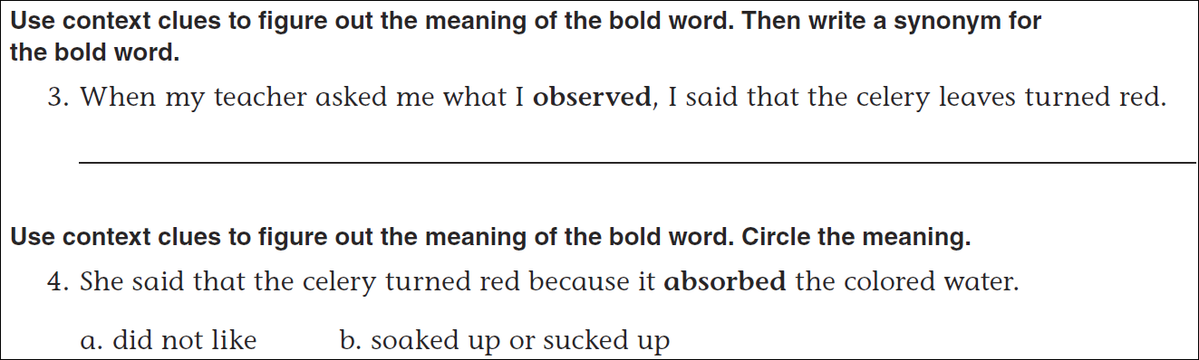
Math
