Spelling / Grammar/ Punctuation
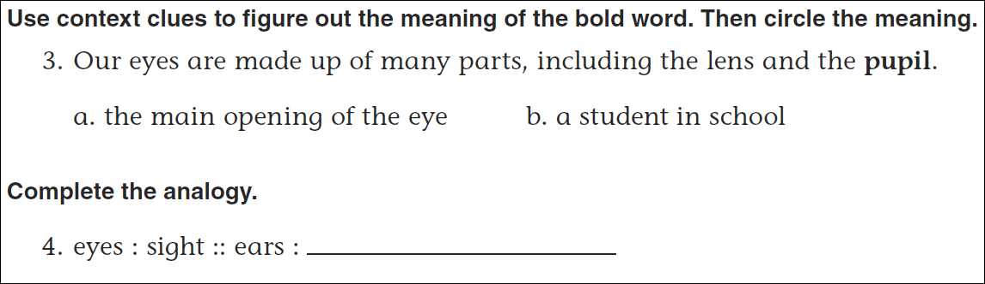
Math
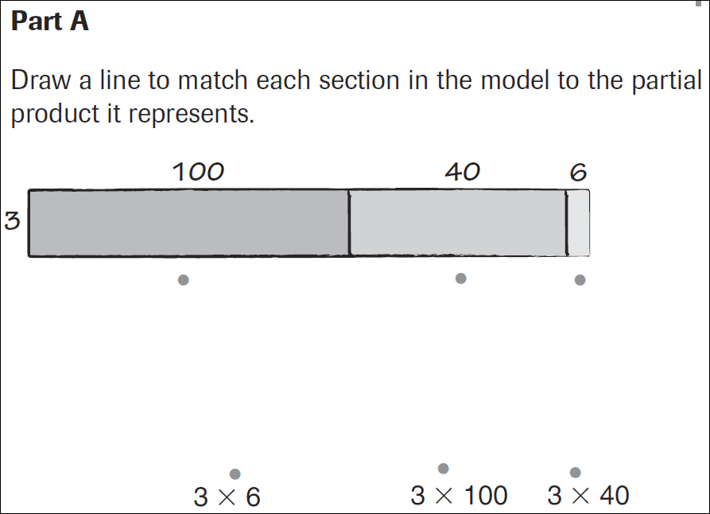
What is the product of the above problem?
