Compare Fractions  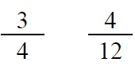  Point! | Line Plot  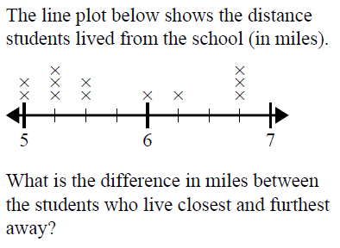  Point!
Area & Perimeter  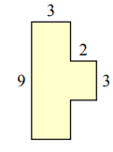  A=_____ P=_____  Point! | Rounding  Point!
Comparison

Lyric & Claire were hungry. The wanted a snack. They decided to eat onions. Lyric ate four times as many onions as Claire. Together they ate 45 onions. How many did each girl eat?

Draw a bar model:

Write the equation:

Point!

Complete the analogy:

Point!
Fix the punctuation:

Point!
Underline the prepositional phrase:

Point!
Circle the meaning of the idiom:

Point!
Choose the correct word:

Point!

