Interpret the remainder  Ashlynn picks apples. She picks 248 apples. She puts 5 in each box. How many boxes will she need for all the apples?  Point! | Number Patterns  Make a pattern. Start at 5. Rule: multiply by two and subtract one. What is the 5th number?  Point!
Area & Perimeter  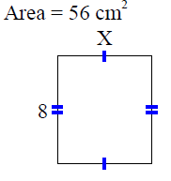  A=_____ P = _______  Point! | Measure Degrees  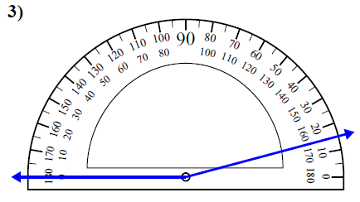  Point!
Comparison

Riley and Bree grow cacti. The word cacti is the plural form of cactus. Together they grow 440 cacti. Riley grows three times as many as Bree. How many does each girl grow?

Draw a bar model:

Write the equation:

Point!

Complete the analogy:

Point!
Fix the punctuation:



Point!
Circle the word that the underlined prepositional phrase modifies



Point!
Circle the meaning of the idiom:

Point!
Circle the correct answer

Point!

