Interpret the remainder  Skylar is a van driver. She has to drive 378 kids every day to school. Her van can hold eight kids at a time. How trips does she need to make with her van?  Point! | Number Patterns  Make a pattern. Start at 7. Rule: subtract three and multiply by three. What is the sixth number?  Point!
Area & Perimeter  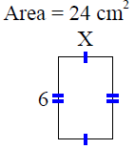  A=_____ P= ______  Point! | Degrees  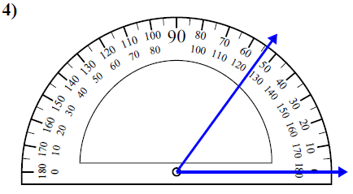  Point!
Comparison

Skylar & Ashlynn fry donuts. They like the kind with sprinkles on them. Together they make 510 donuts. Skylar makes twice as many as Ashlynn. How many donuts does each girl make?

Draw a bar model:

Write the equation:

Point!
Complete the analogy:

Point!
Fix the punctuation:

Point!
Circle the word that the underlined prepositional phrase modifies

Point!
Circle the meaning of the idiom:

Point!
Circle the correct answer

Point!

