Interpret the remainder  Dresdan is a pilot. He has to fly 716 people out of the country. His plane holds six passengers. How many flights does he need to make to get everyone out?  Point! | Line Plot  Make a pattern. Start at 2. Rule: multiply by five and subtract three. What is the eighth number?  Point!
Area & Perimeter  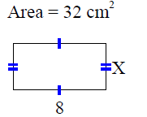  A= _____ P=______  A=_____ P=_____  Point! | Degrees  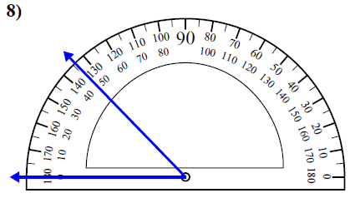  Point!
Comparison

Serra & Saziana love math. They just love it! Together they solve 560 hard math problems. They get a headache from all the thinking they have to do. Saziana solves six times as many problems as Serra. How many problems does each girl solve?

Draw a bar model:

Write the equation:

Point!
Complete the analogy:

Point!
Fix the punctuation:

Point!
Circle the word that the underlined prepositional phrase modifies

Point!
Circle the meaning of the idiom:

Point!
Circle the correct answer

Point!

