Interpret Remainders  Kamren is a basketball coach. He has 326 players. He wants to divide them up into teams of nine. How more kids will be needed to make one more team?  Point! | Number Patterns  Make a patter. Start at 3. Multiply by five and then subtract ten. What is the fifth number?  Point!
Find the area of just the walkway  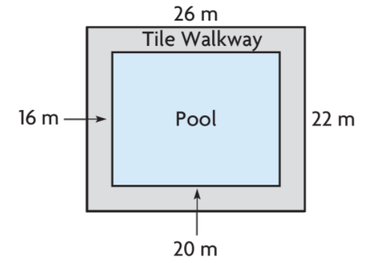  A= ____  Point! | Degrees  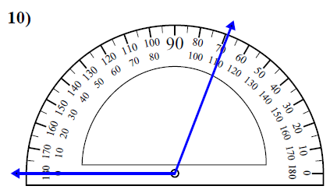  Point!
Comparison

Valerie and Abigail like to fish. They go fishing all the time. Together they catch 180 fish. Valerie catches three times as many as Abigail. How many does each girl catch?

Draw a bar model:

Write the equation:

Point!

Complete the analogy:

Point!
Fix the punctuation:

Point!
Circle the word that the underlined prepositional phrase modifies

Point!
Circle the meaning of the idiom:

Point!
Circle the correct answer

Point!

