Compare Fractions  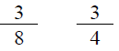  Point! | Line Plot  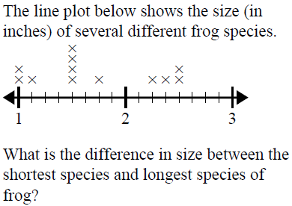  Point!
Find the area of just the gray part  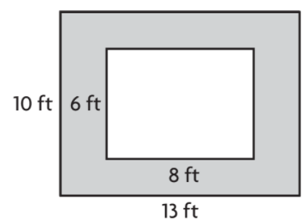  A= _______  Point! | Rounding  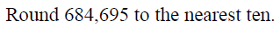  Point!
Comparison
Jaxon & Sebastian like to wrestle penguins. Sometimes they win. Together they wrestle 260 penguins. It is hard work. Jaxon wrestles three times as many penguins as Sebastian. How many does each boy wrestle?

Draw a bar model:

Write the equation:

Point!

Complete the analogy:

Point!
Fix the punctuation:

Point!
Circle the word that the underlined prepositional phrase modifies

Point!
Circle the meaning of the idiom:

Point!
Circle the correct answer

Point!

