Compare Fractions  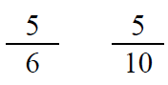  Point! | Line Plot  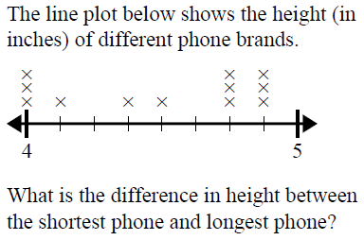  Point!
Area & Perimeter  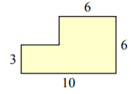  A=_____ P=_____  Point! | Rounding  Point!
Comparison

Soren & Dominik collected Easter eggs from the Easter Bunny. They know rabbits lay eggs….right? Together they collected 32 eggs. Soren collected three times as many eggs as Dominik. How many eggs did each boy collect?

Draw a bar model:

Write the equation:

Point!

Complete the analogy:

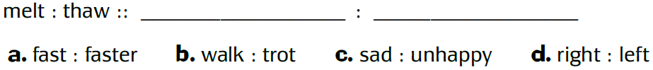

Point!
Fix the punctuation:

Point!
Underline the prepositional phrase:

Point!
Circle the meaning of the idiom:

Point!
Choose the correct word:

Point!

