Compare Fractions  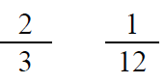  Point! | Line Plot  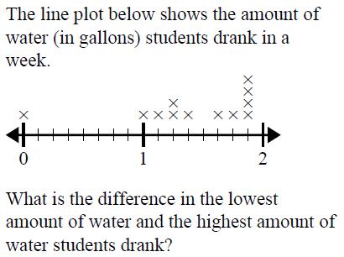  Point!
Area & Perimeter  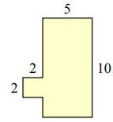  A=_____ P=_____  Point! | Rounding  Point!
Comparison

Noah & Matthias like to eat potatoes. Potatoes are good. Together they ate 70 potatoes. Noah ate six times as many as Matthias. How many did each boy eat?

Draw a bar model:

Write the equation:

Point!

Complete the analogy:

Point!
Fix the punctuation:

Point!
Underline the prepositional phrase:

Point!
Circle the meaning of the idiom:



Point!
Choose the correct word:

Point!

