Compare Fractions  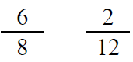  Point! | Line Plot  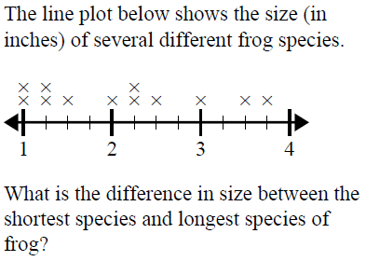  Point!
Area & Perimeter  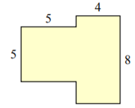  A=_____ P=_____  Point! | Rounding  Point!
Comparison

Avery & Abigail babysit for babies. Together they watch 42 babies. Avery watches six times as many babies as Abigail. Avery gets rich. How many babies does each girl watch?

Draw a bar model:

Write the equation:

Point!

Complete the analogy:

Point!
Fix the punctuation:



Point!
Underline the prepositional phrase:

Point!
Circle the meaning of the idiom:



Point!
Choose the correct word:

Point!

