Compare Fractions  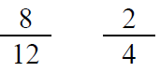  Point! | Line Plot  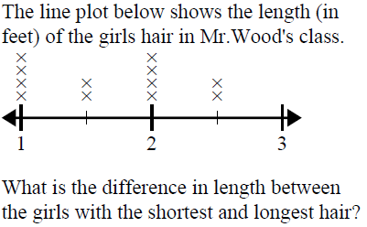  Point!
Area & Perimeter  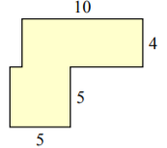  A=_____ P=_____  Point! | Rounding  Point!
Comparison

Frank & Randall collect worms for fun. Randall collects three times as many as Frank. Together they collect 240 worms. Oh, what fun! How many worms does each boy collect?

Draw a bar model:

Write the equation:

Point!

Complete the analogy:

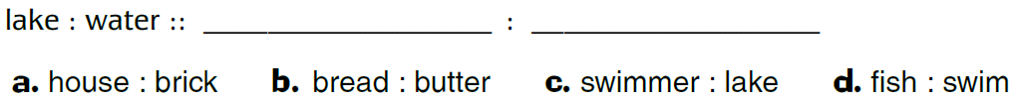

Point!
Fix the punctuation:

Point!
Underline the prepositional phrase:

Point!
Circle the meaning of the idiom:

Point!
Choose the correct word:

Point!

