Compare Fractions  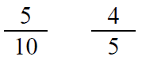  Point! | Line Plot  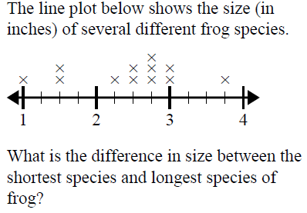  Point!
Area & Perimeter  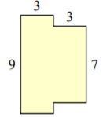  A=_____ P=_____  Point! | Rounding  Point!
Comparison

Blaine & Anders smell roses. They smell a lot. Together they smell 720 roses. I told you, they smell a lot. They smell with their noses. Blaine smells seven times as many as Anders. How many does each boy smell?

Draw a bar model:

Write the equation:

Point!

Complete the analogy:

Point!
Fix the punctuation:

Point!
Underline the prepositional phrase:

Point!
Circle the meaning of the idiom:

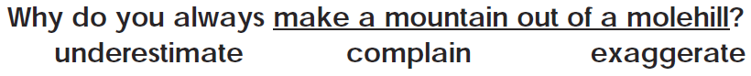

Point!
Circle the incorrect word. Then, fix it.

Point!

