Spelling / Grammar/ Punctuation
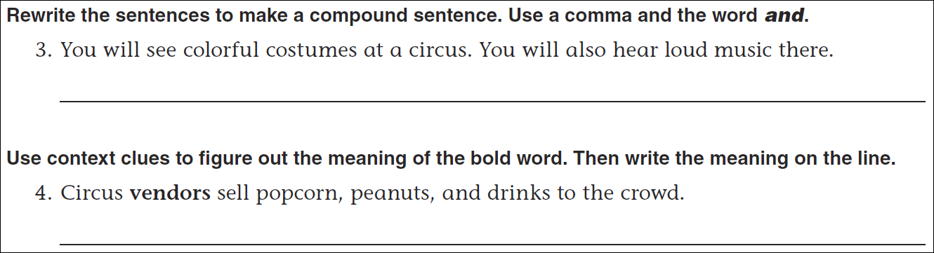
Math
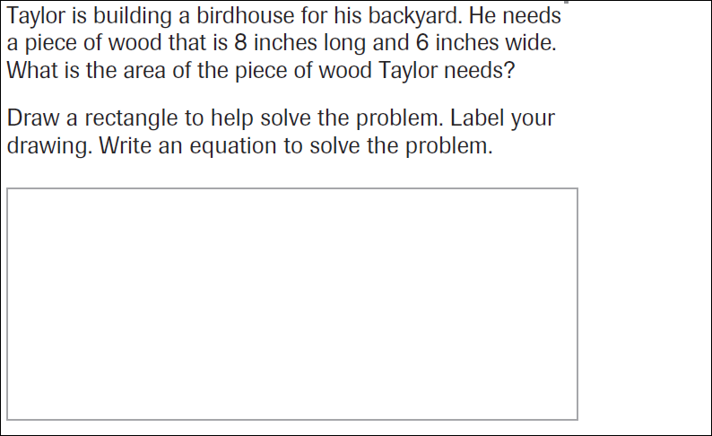
6x6= | 6x7= | 6x8= | 6x9=
7x6= | 7x7= | 7x8= | 7x9

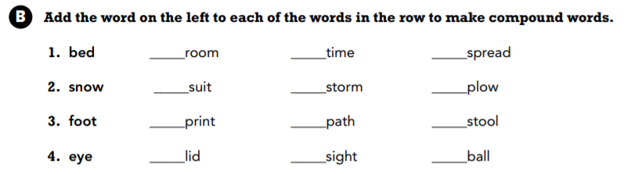

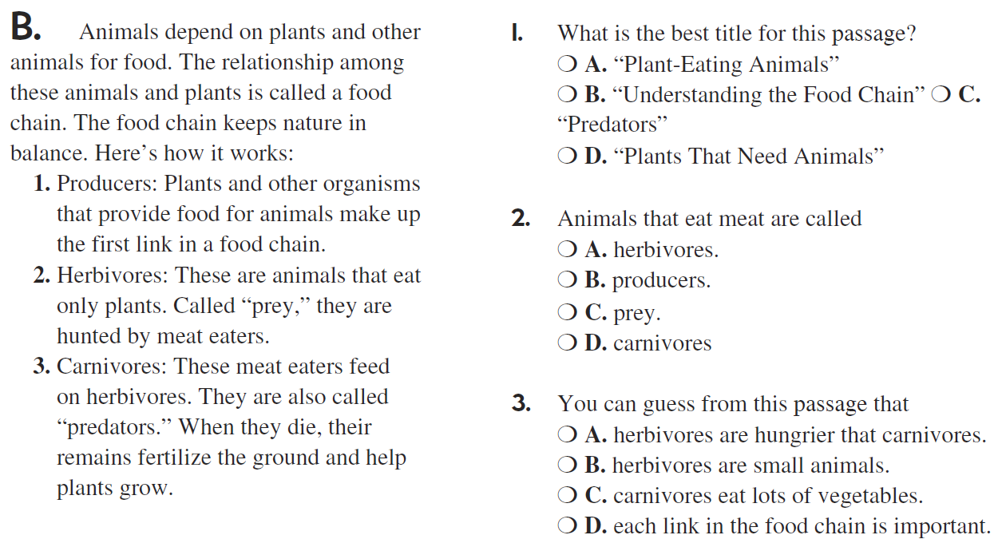

A noun is a person, place or thing. Write six nouns of your own.

