Spelling / Grammar/ Punctuation
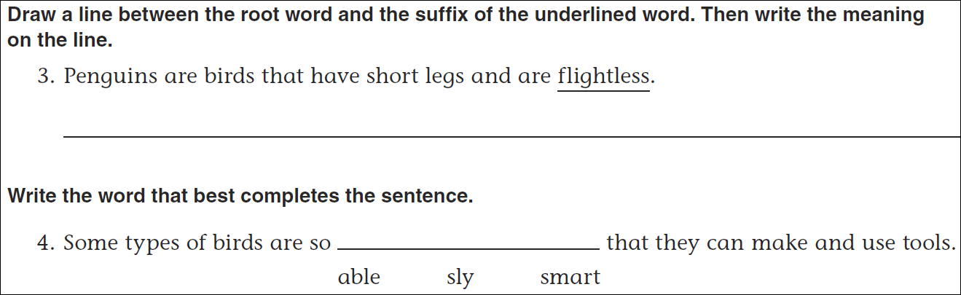
Math
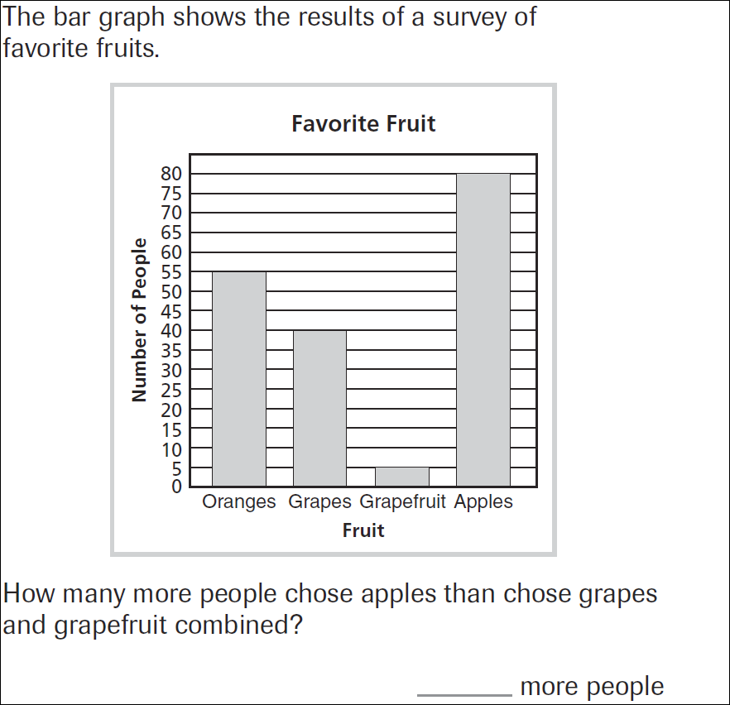
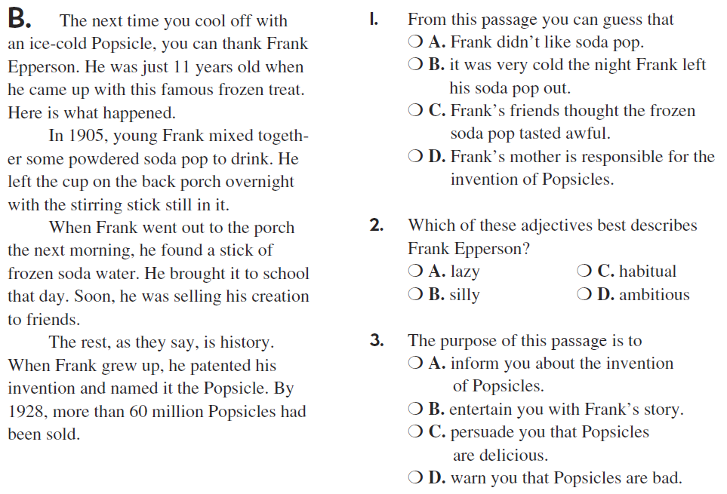
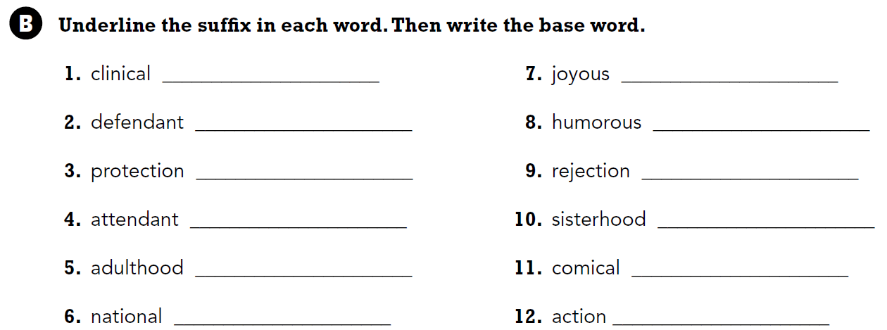

Adjectives describe nouns. Write four adjectives that describe pizza.

