Spelling / Grammar/ Punctuation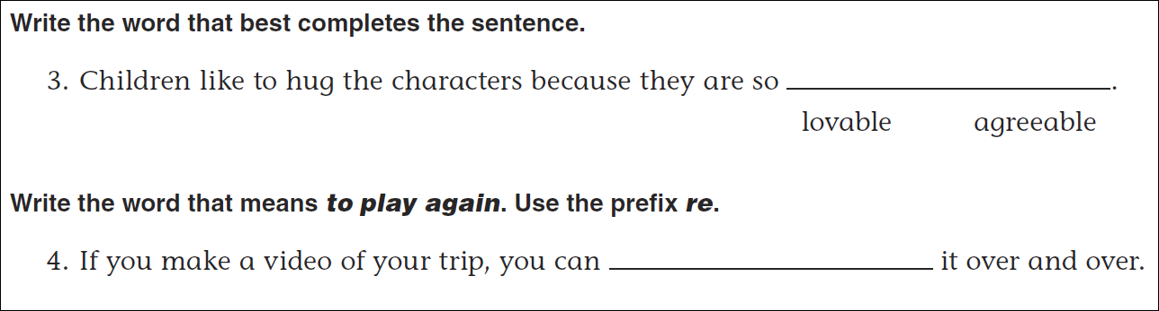
Math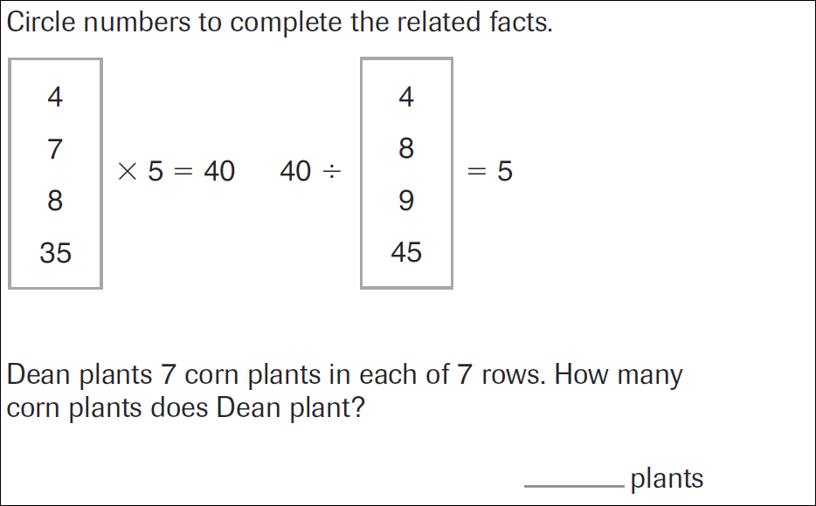

6x6=____ | 7x7=____ | 8x8=____ | 9x9=____
81÷___=9 | 64÷___=8 | 49÷___=7 | 36÷___=6

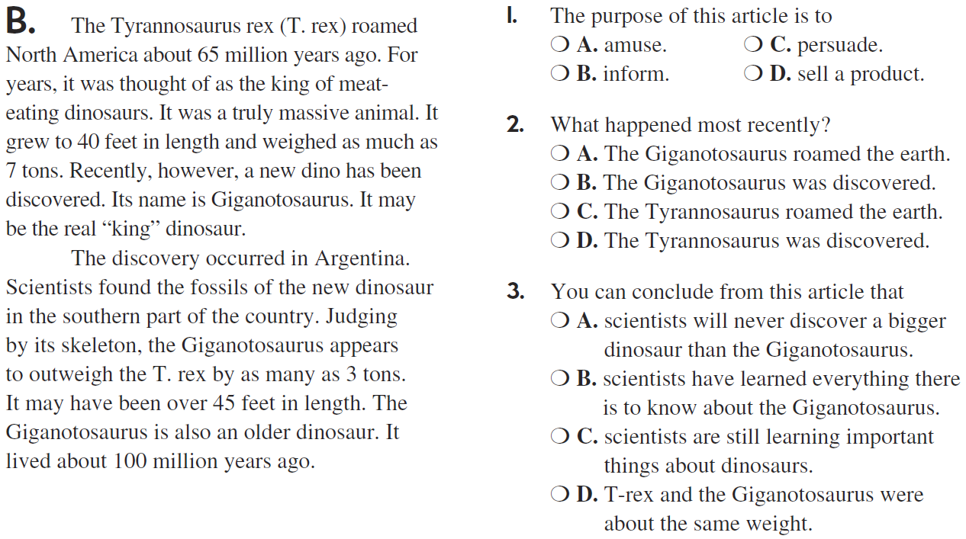

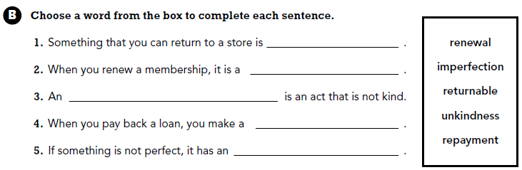

Use part of the question in your answer. Where were you born?

