Spelling / Grammar/ Punctuation
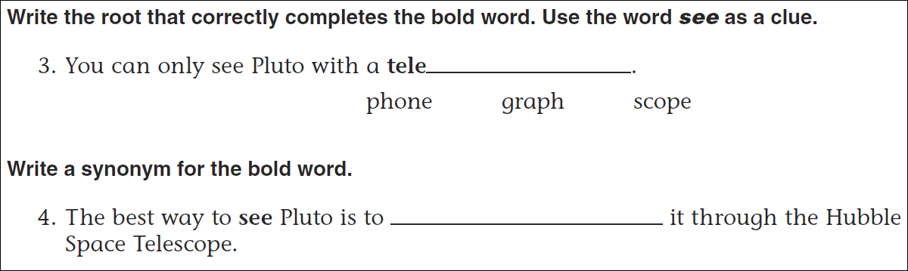
Math
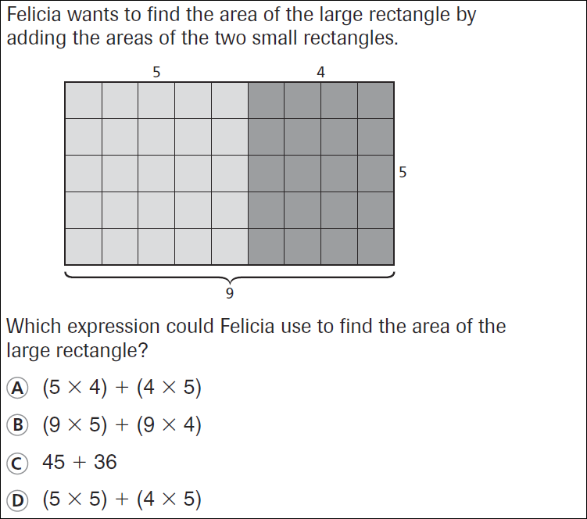
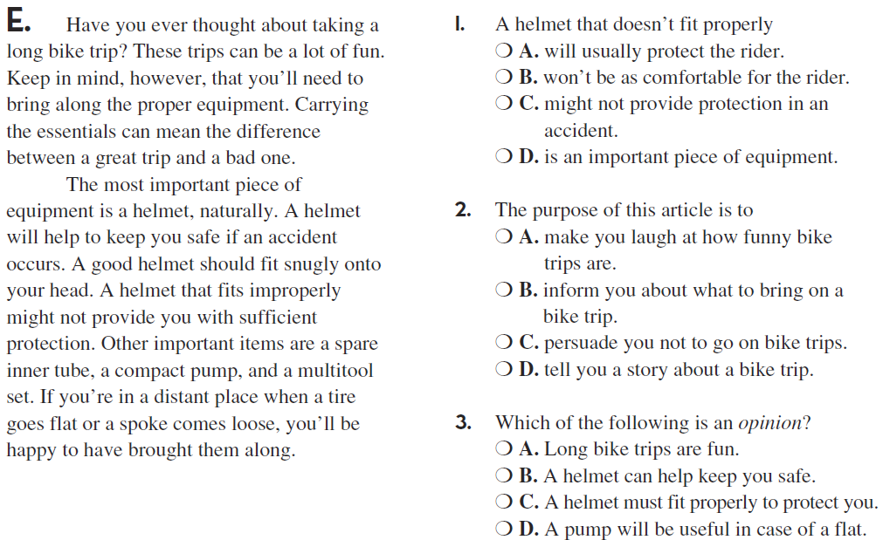

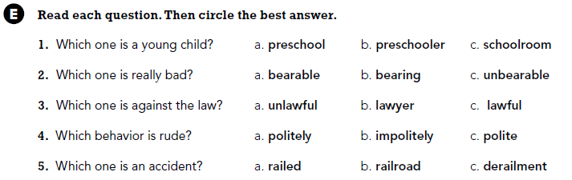

Use part of the question in your answer. What is your favorite food?

