Spelling / Grammar/ Punctuation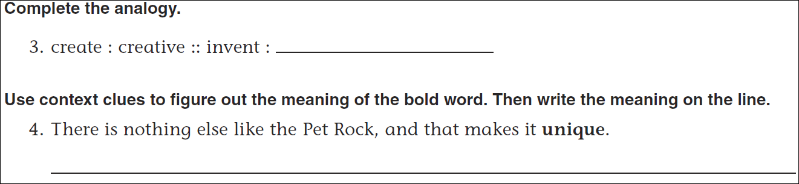
Math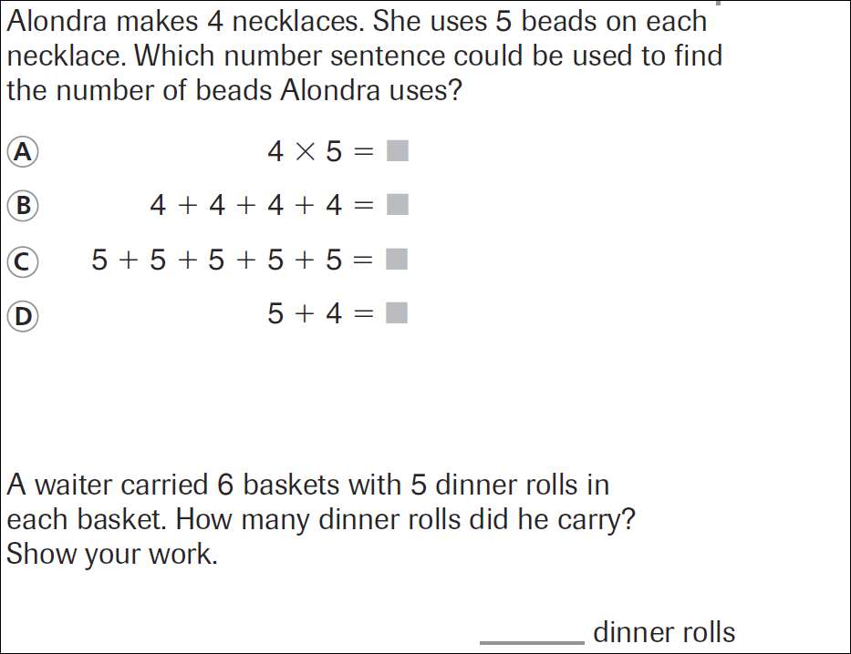
24 ÷ 6 = | 18 ÷ 6 = | 36 ÷ 6 = | 60 ÷ 6 =
54 ÷ 6 = | 12 ÷ 6 = | 42 ÷ 6 = | 48 ÷ 6 =

