Spelling / Grammar/ Punctuation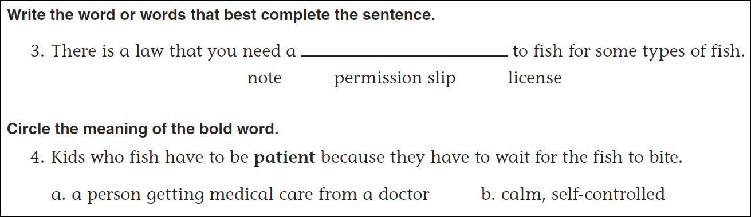
Math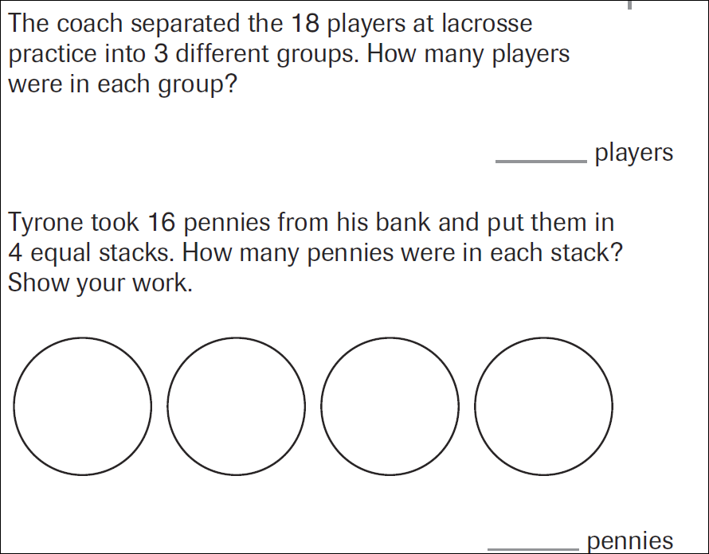
35÷7= | 56÷7= | 21÷7= | 49÷7=

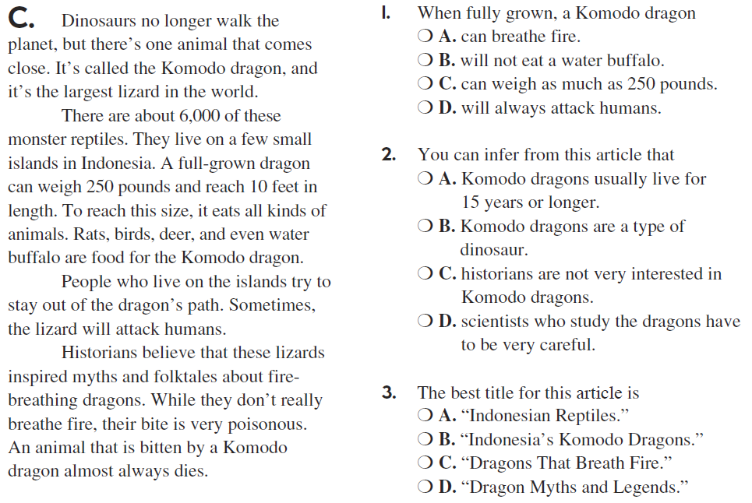

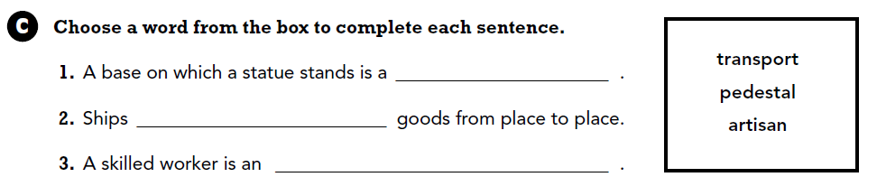

Use part of the question in your answer. What is a product?

