Spelling / Grammar/ Punctuation
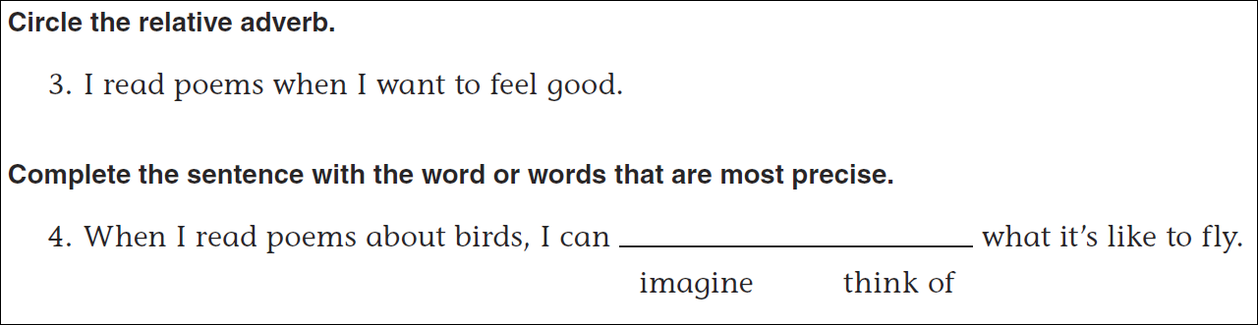
Math
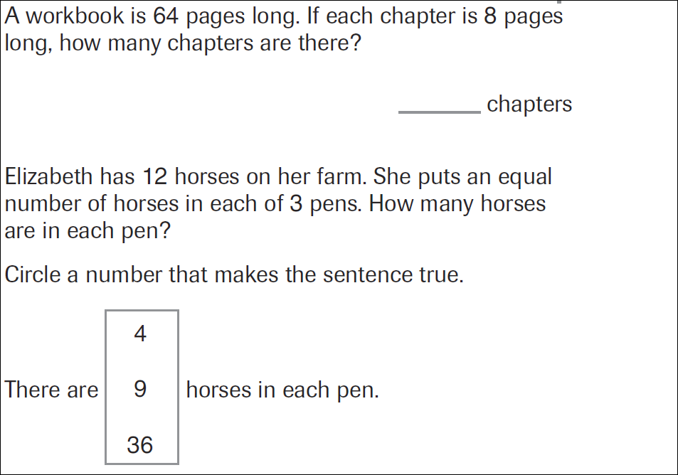
64÷8= | 32÷8= | 24÷8= | 48÷8=
72÷8= | 80÷8= | 16÷8= | 8÷8=

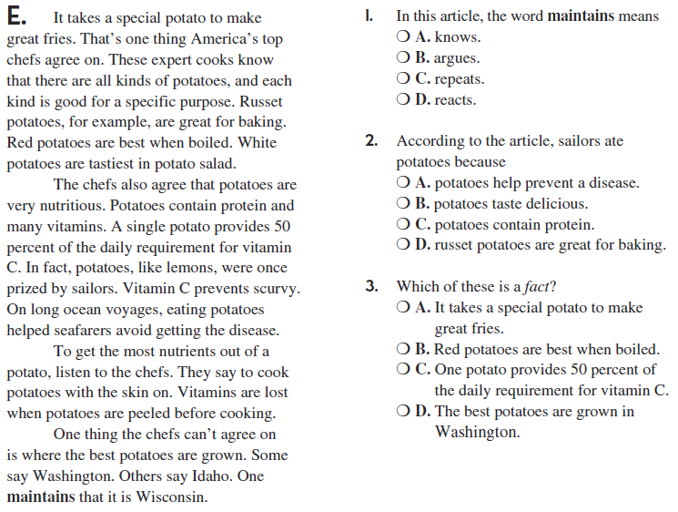
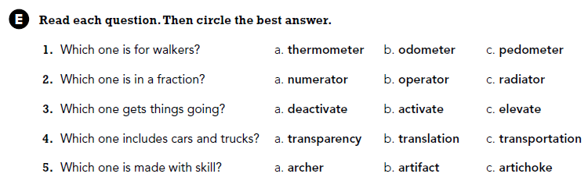

Use part of the question in the answer. Who is the president of the U. S. ?

