Spelling / Grammar/ Punctuation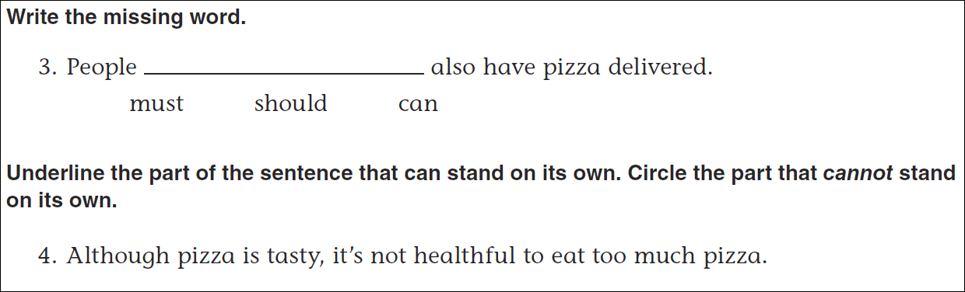
Math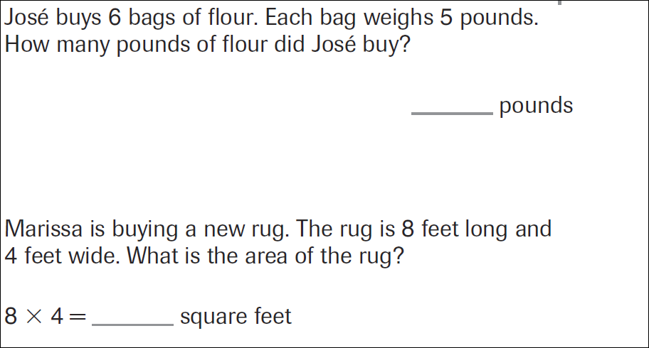
64÷8= | 56÷8= | 32÷8= | 24÷8=
72÷8= | 48÷8= | 40÷8= | 16÷8=

