Spelling / Grammar/ Punctuation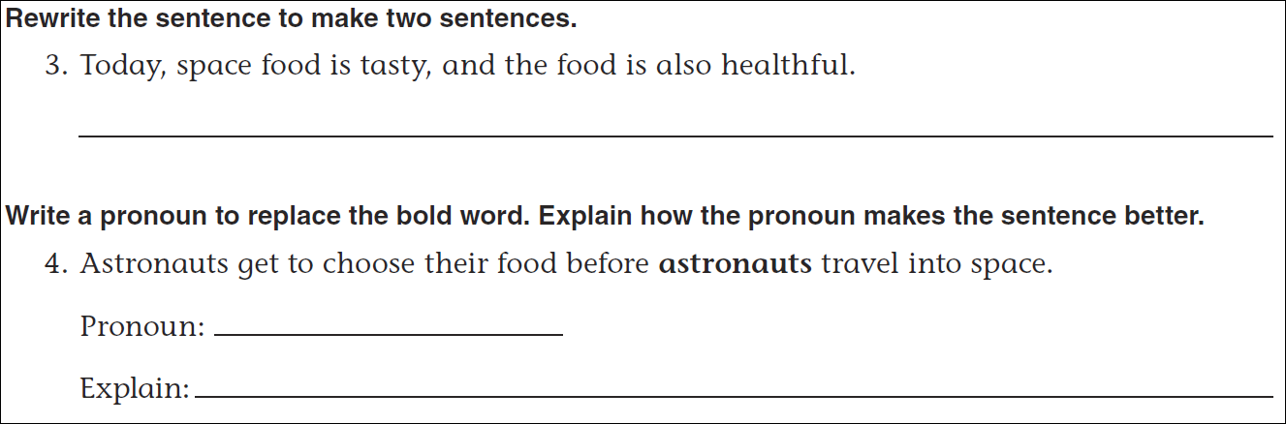
Math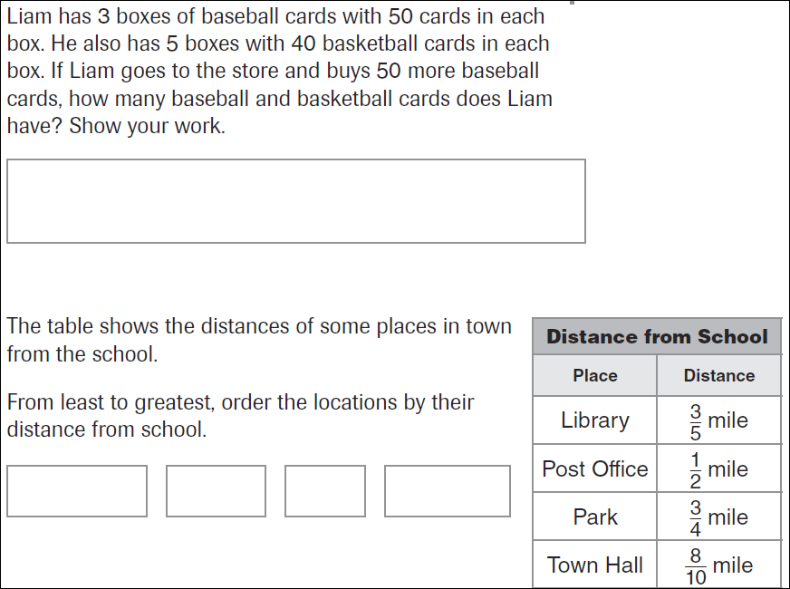
49÷7= | 64÷8= | 36÷6= | 81÷9=

