Spelling / Grammar/ Punctuation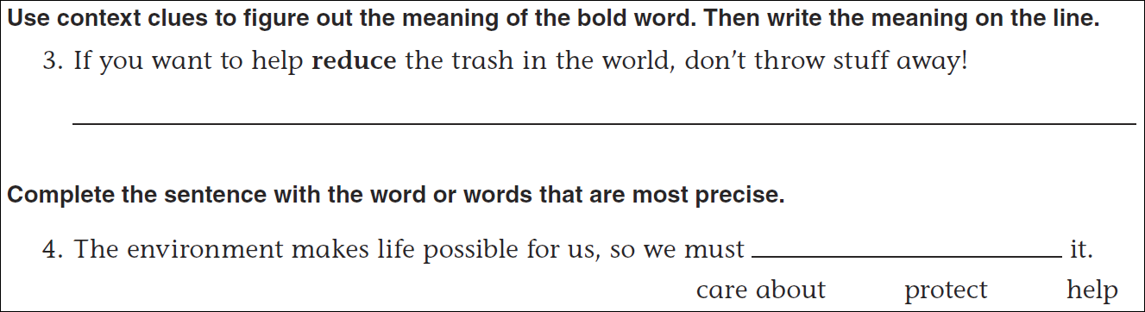
Math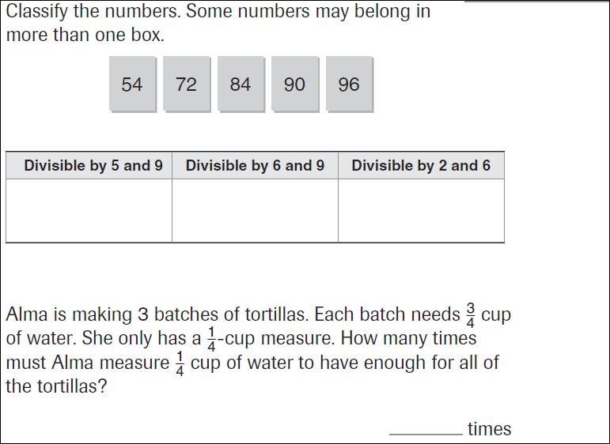
27÷3= | 18÷3= | 12÷3= | 15÷3=

