Spelling / Grammar/ Punctuation
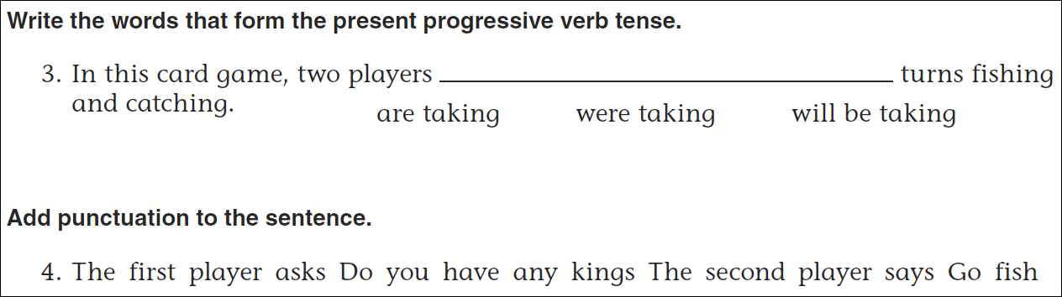
Math
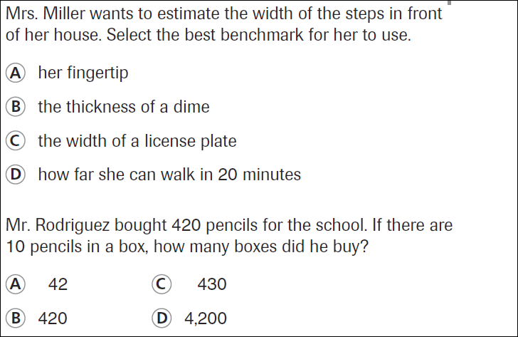
5÷2= | 7÷2= | 9÷2= | 11÷2=
13÷2= | 15÷2= | 17÷2= | 19÷2=

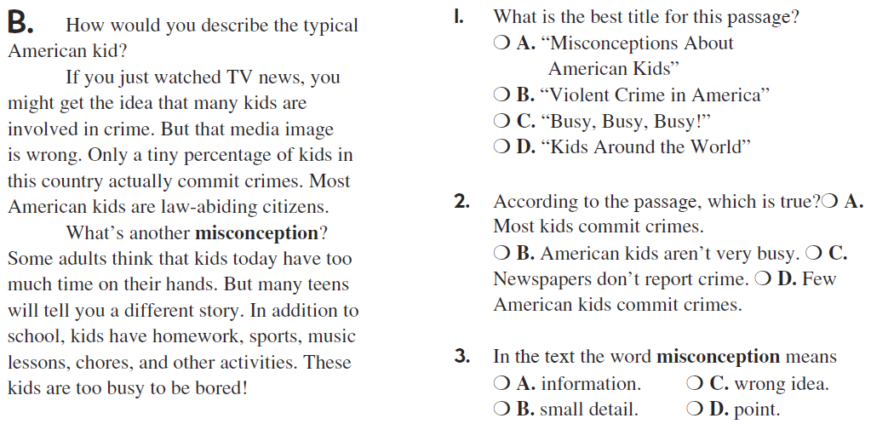

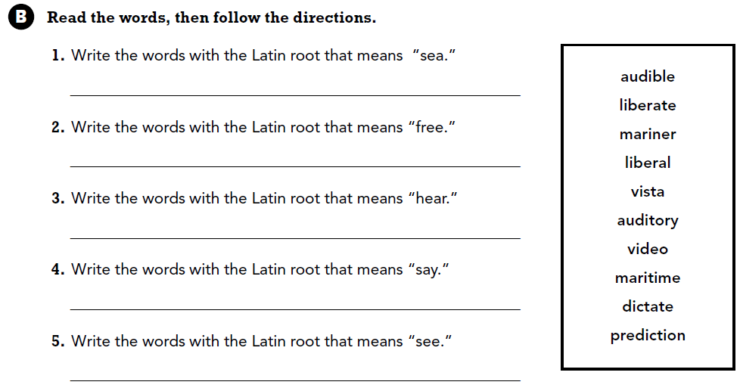

Use part of the question in your answer. What did you have for dinner last night?

