Spelling / Grammar/ Punctuation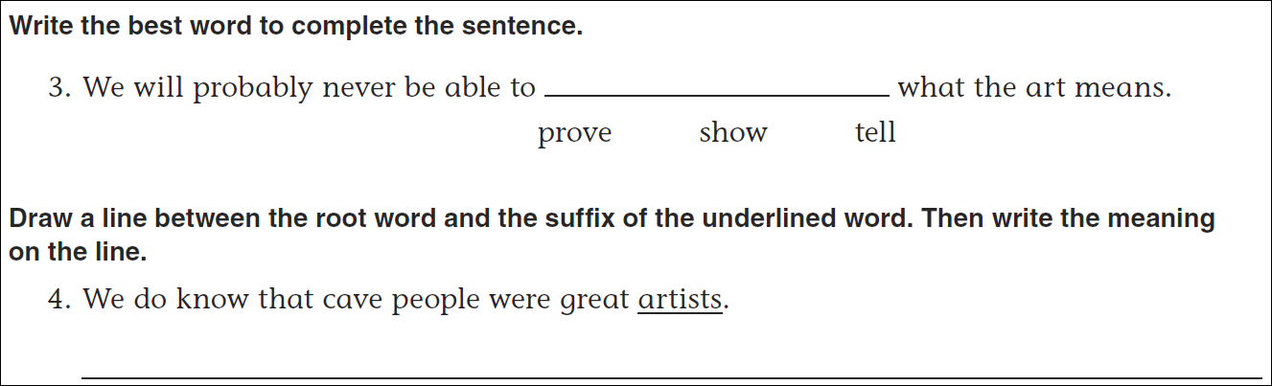Math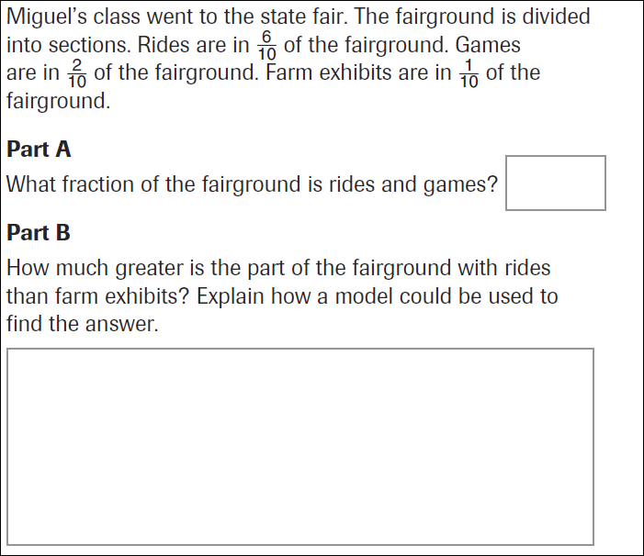
5÷3= | 7÷3= | 8÷3 | 10÷3=
