Spelling / Grammar/ Punctuation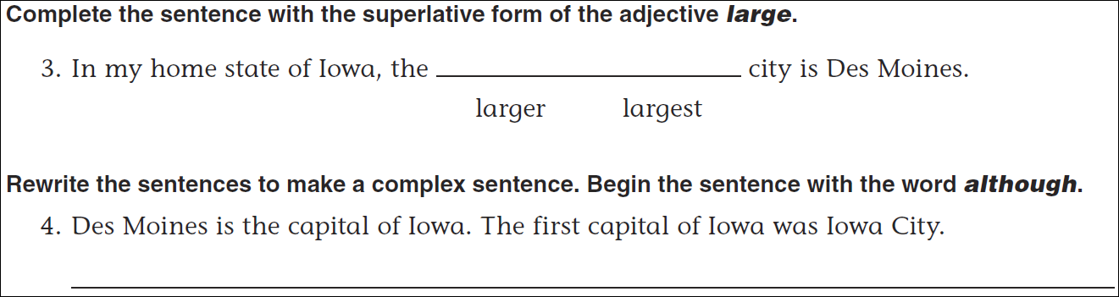Math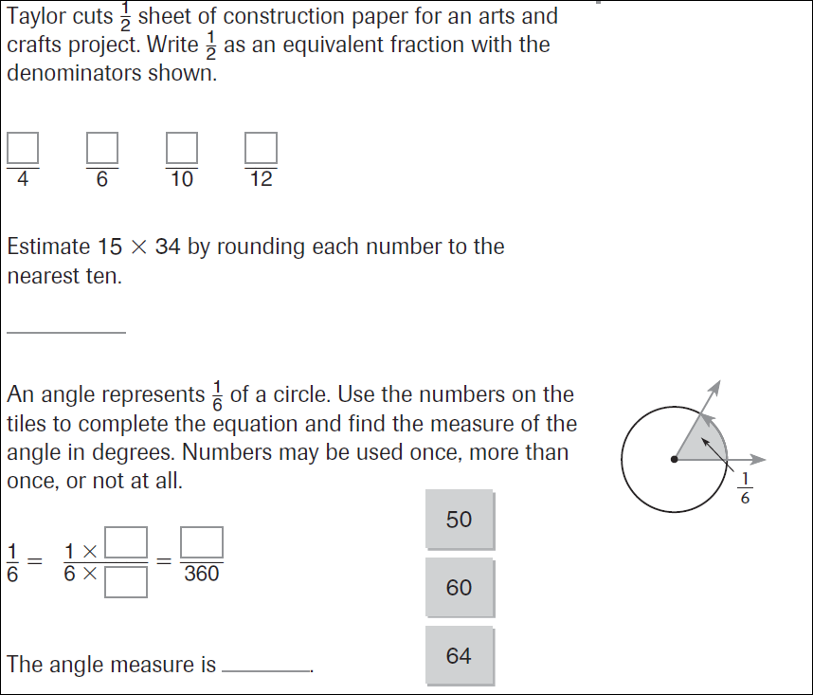
11÷5= | 13÷5= | 18÷5= | 24÷5=
