Spelling / Grammar/ Punctuation
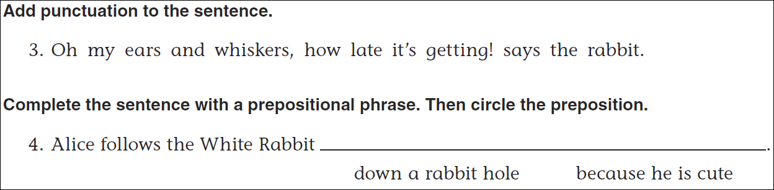
Math
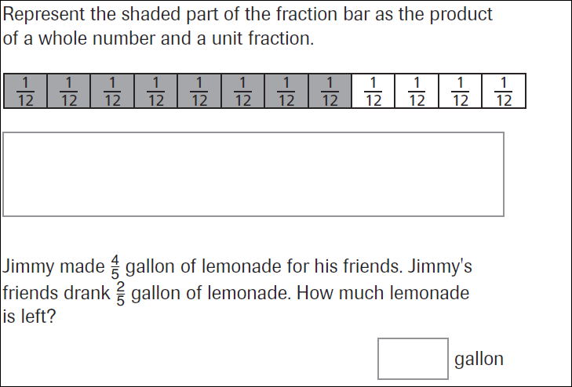
25÷6= | 34÷6= | 47÷6= | 19÷6=

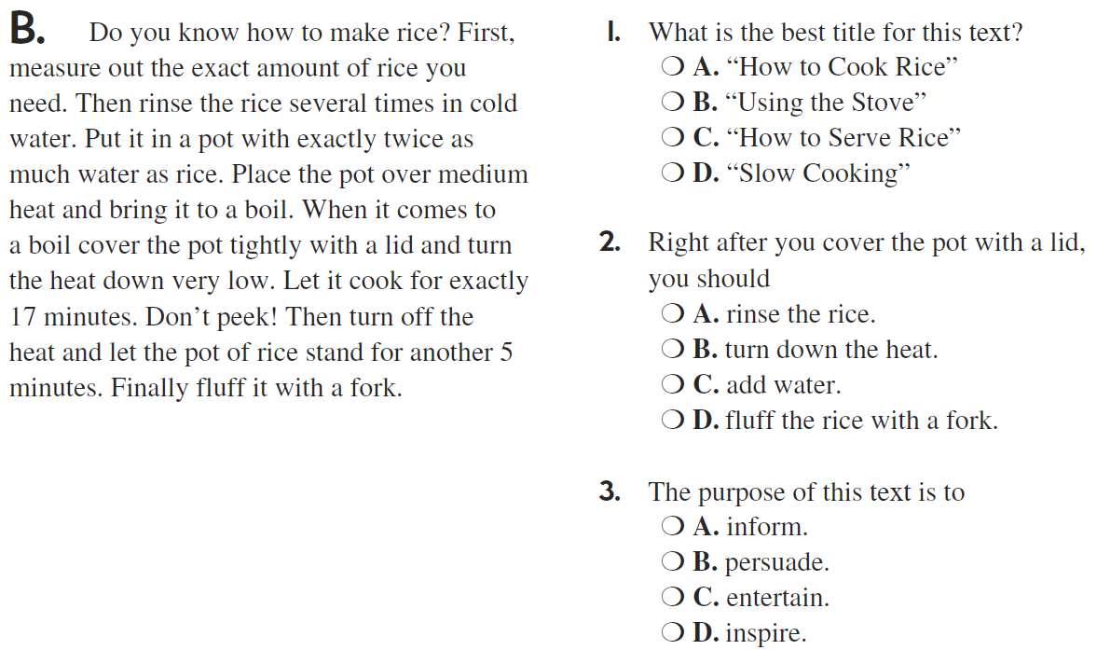

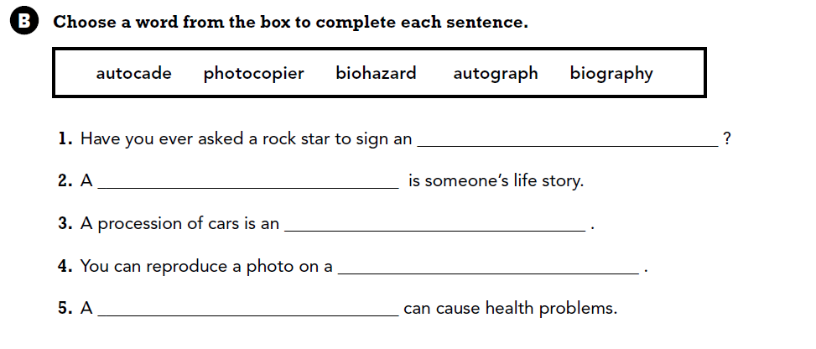

Use part of the question in the answer. How many months are in a year?

