Spelling / Grammar/ Punctuation
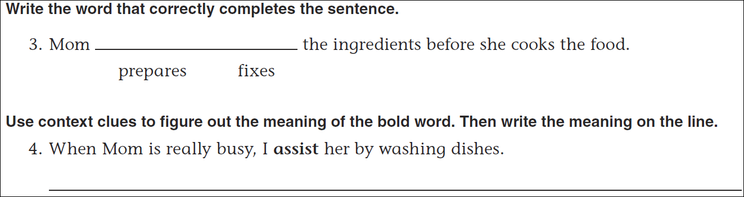
Math
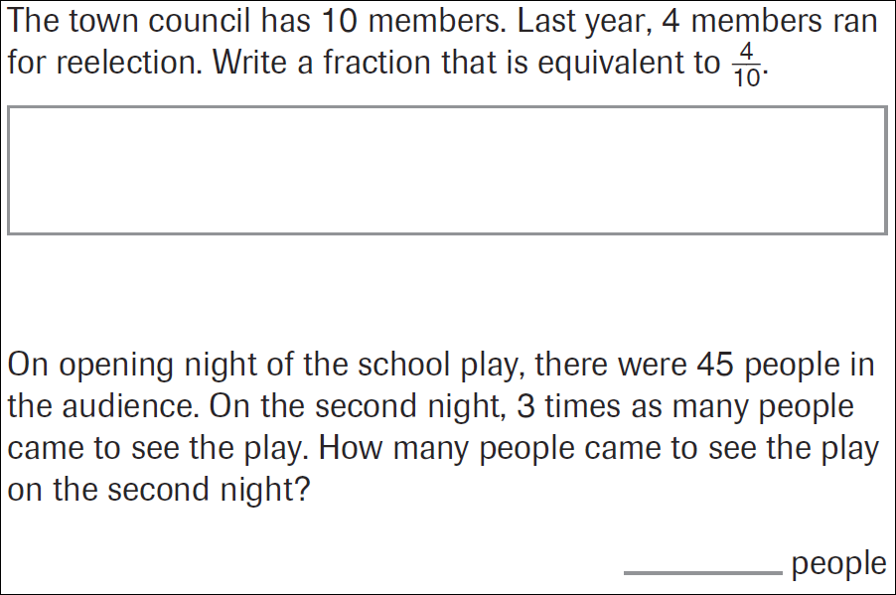
24÷9= | 35÷9= | 17÷9= | 47÷9=

