Spelling / Grammar/ Punctuation
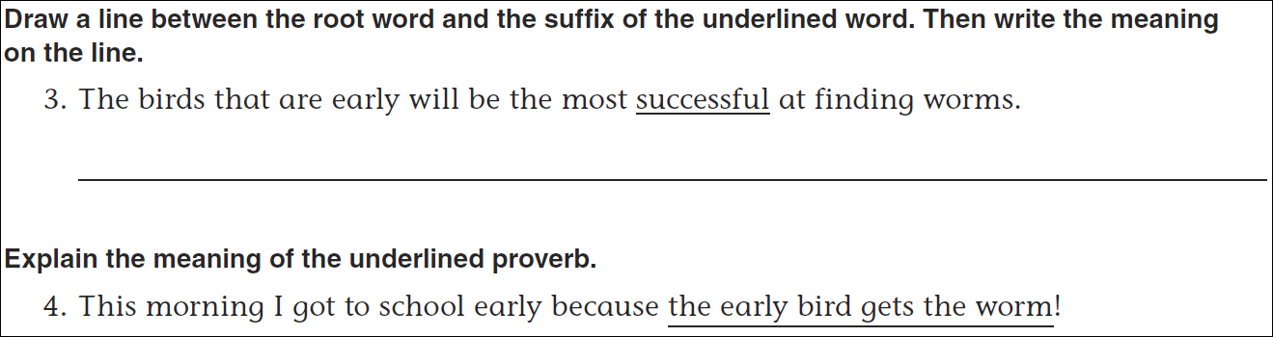
Math
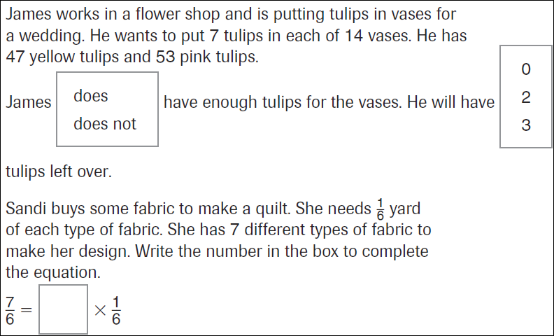
12÷5= | 17÷6= | 16÷3= | 14÷8=
8÷3= | 9÷4= | 11÷3= | 13÷5=

