Spelling / Grammar/ Punctuation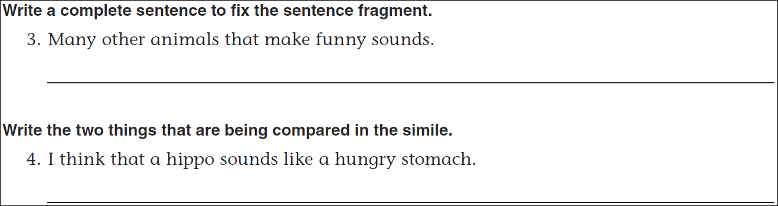
Math
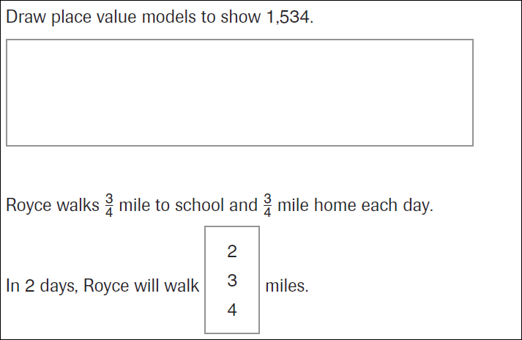
20÷3= | 20÷4= | 20÷5= | 20÷6=
20÷7= | 20÷8= | 20÷9= | 20÷10=

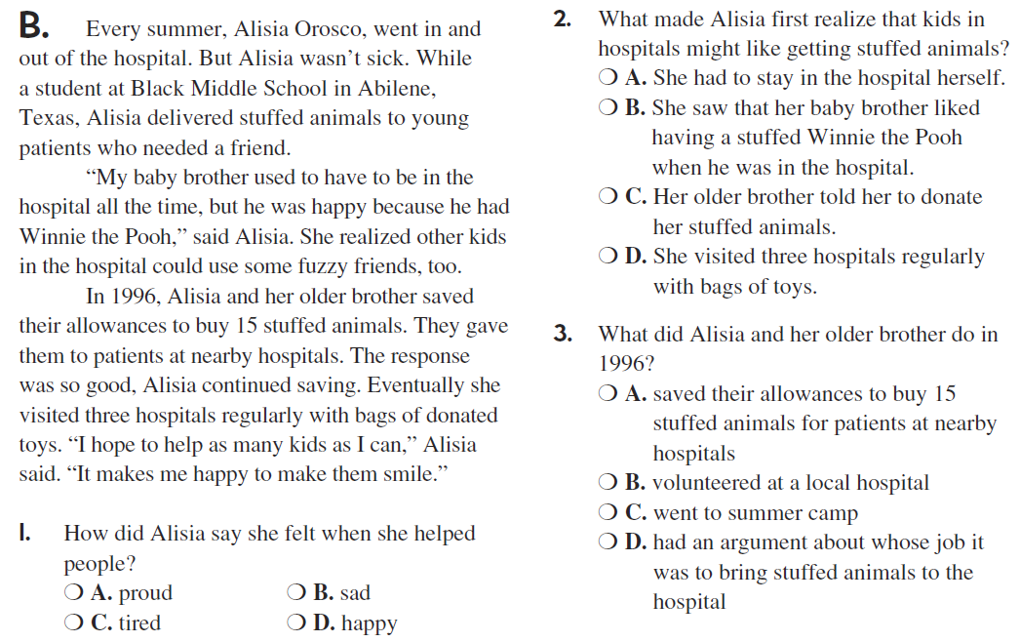

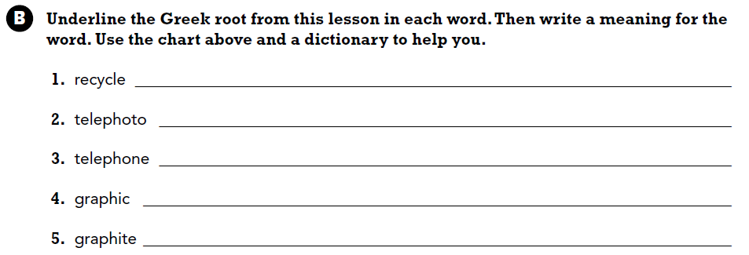

Use part of the question in the answer. How many days are in a week?

