Spelling / Grammar/ Punctuation
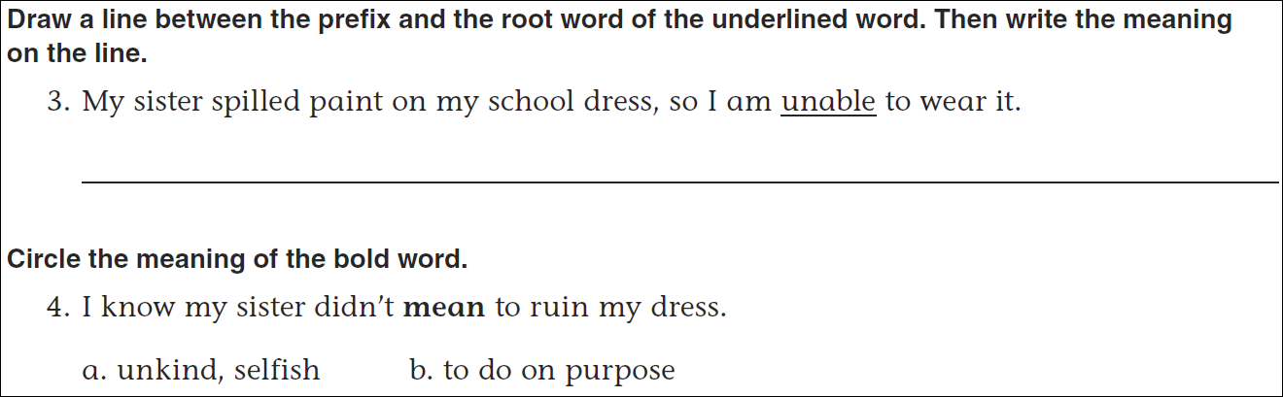
Math
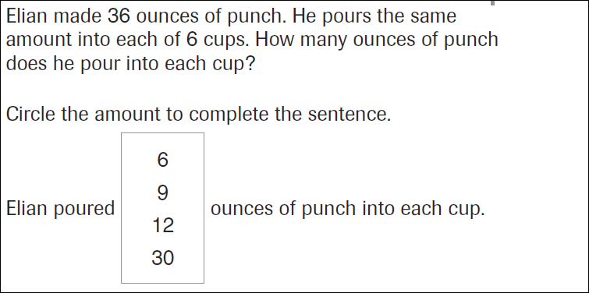
6x6= | 6x7= | 6x8=
7x6= | 7x7= | 7x8=

