Spelling / Grammar/ Punctuation
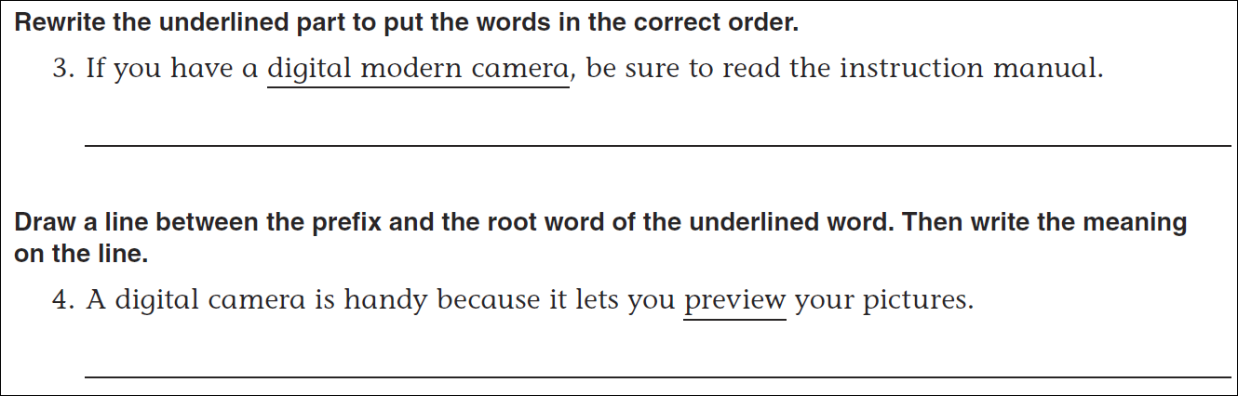
Math
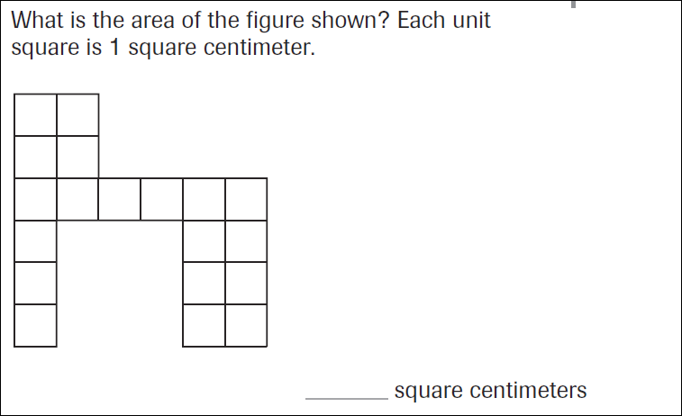
What is the perimeter, or distance around, the above shape?

_____________ cm

