Spelling / Grammar/ Punctuation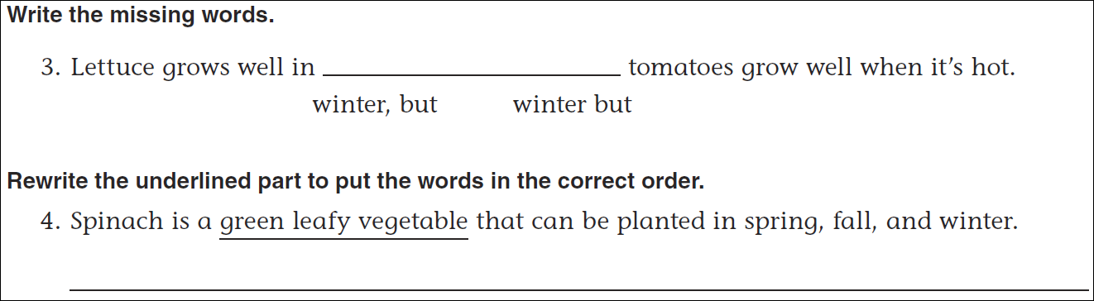
Math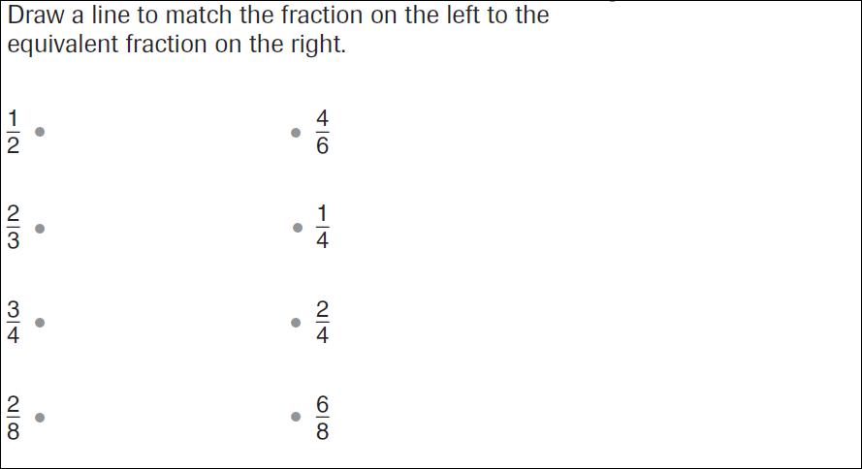
2x____ = 24 | 3x______ = 24 | 4x_____= 24
6x_____ = 24 | 8x______=24 | 12x_____=24

