Spelling / Grammar/ Punctuation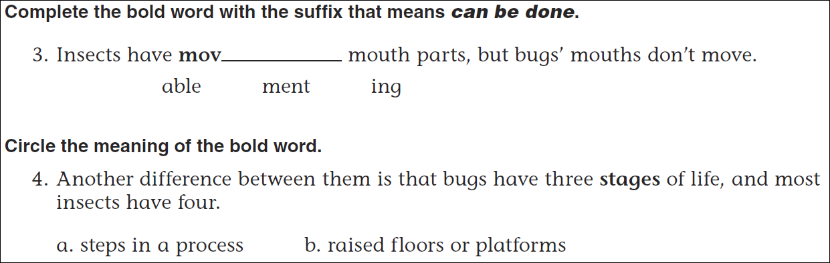
Math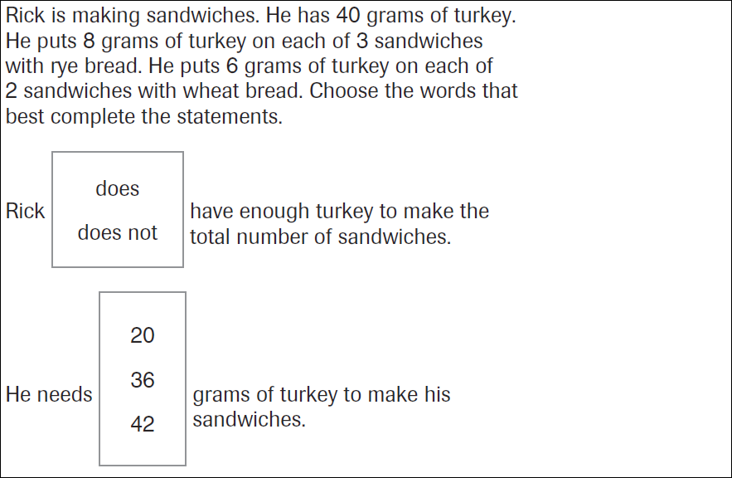

2x____= 18 | 3x____=18 | 18= 6x_____ | 18=_____x9

