Spelling / Grammar/ Punctuation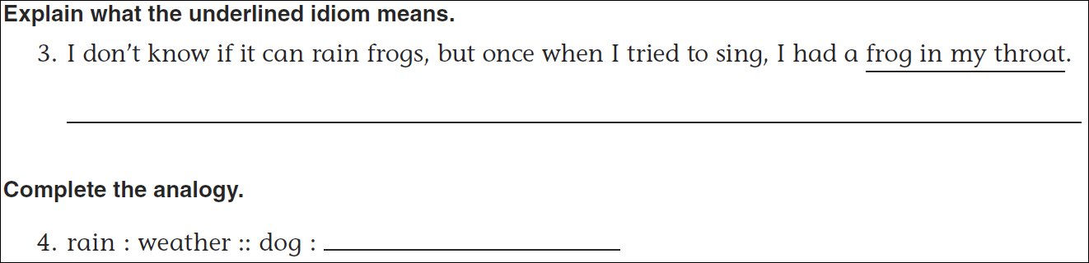
Math
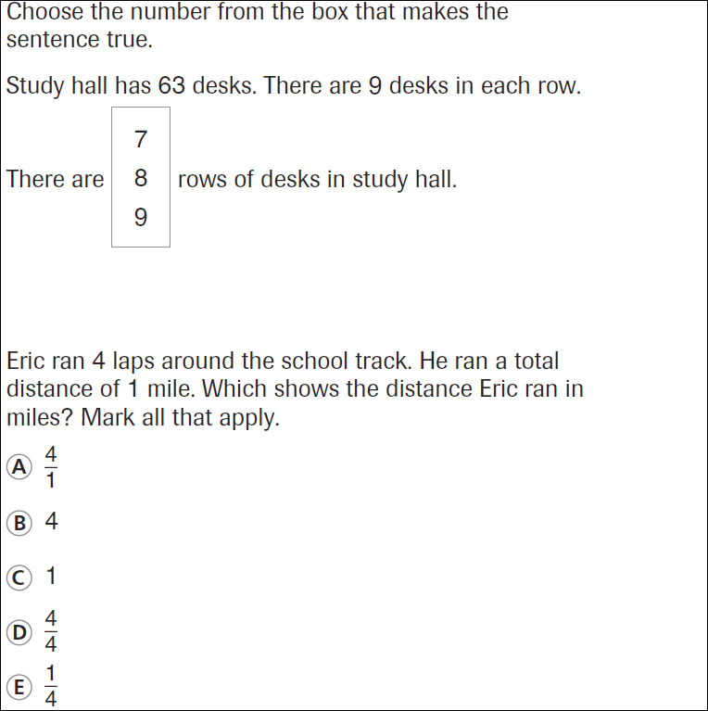
12 = ____x3 | 4x_____=12 | 12 = 6X____ | 2x____=12
