Spelling / Grammar/ Punctuation
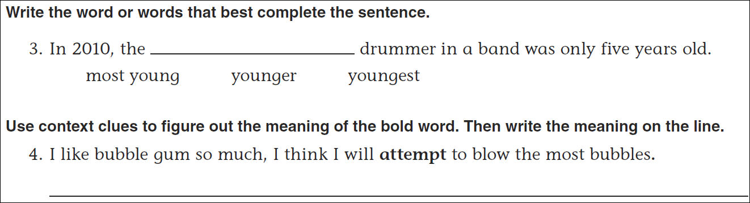
Math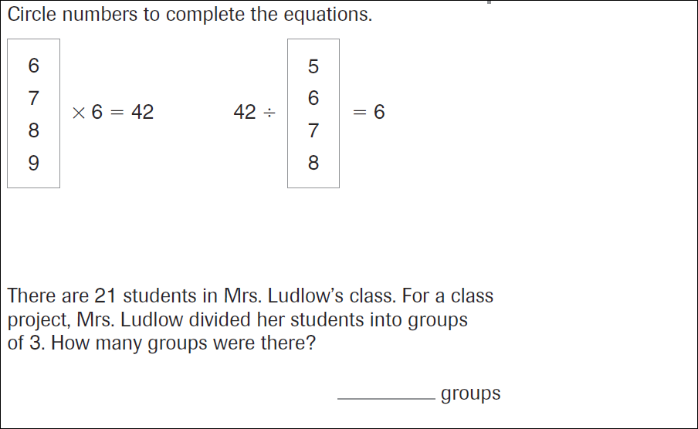
9x4= ____ | 6x6=____ | 2x18=____ | 3x12=____
36=12x____ | 36=____x4 | 36=2x_____ | 36=6x____

