Spelling / Grammar/ Punctuation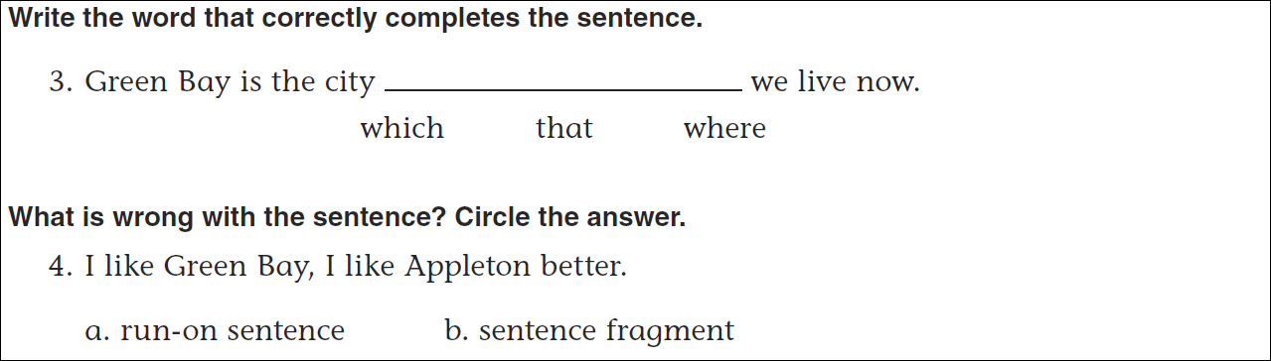
Math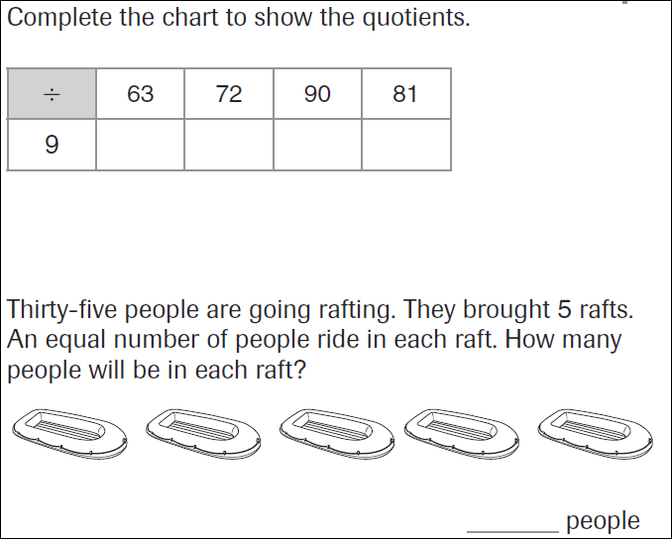
54=______x6 | 56=7x_____ | 48=8x______ | 42=_____x7
