Spelling / Grammar/ Punctuation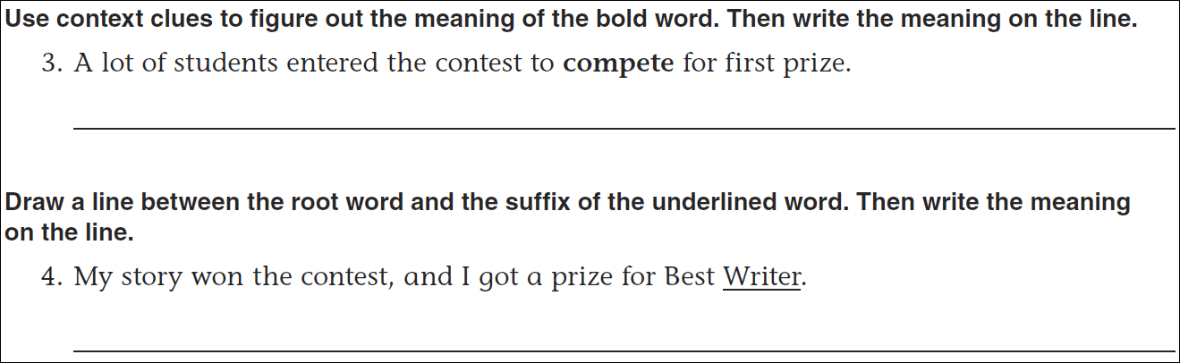
Math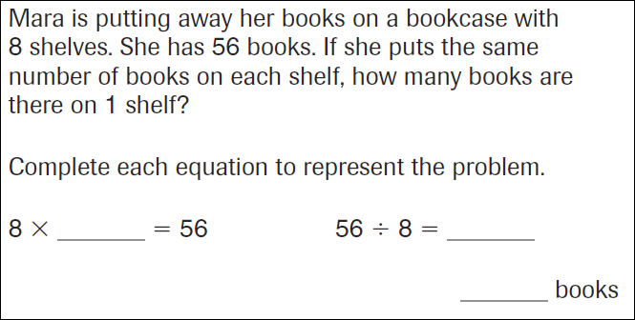
6x6=____ | 6x7=_____ | 6x8=______ | 6x9=_____
7x6=____ | 7x7=_____ | 7x8=______ | 7x9=_____
8x6=____ | 8x7=_____ | 8x8=______ | 8x9=_____

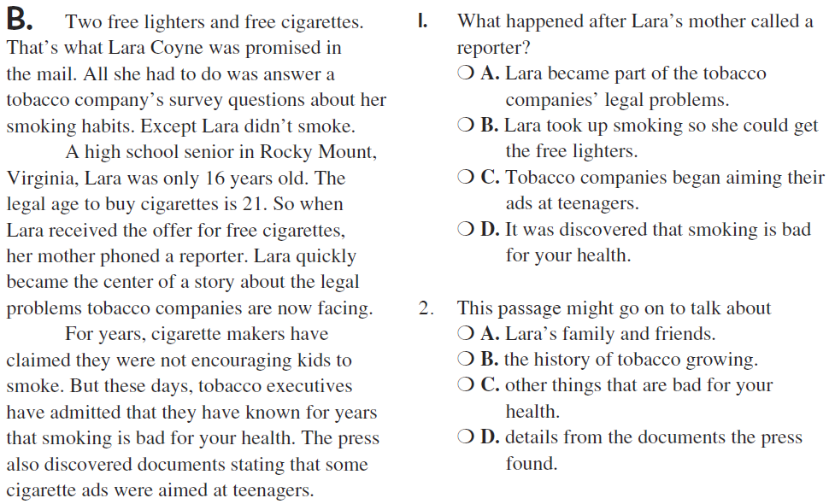
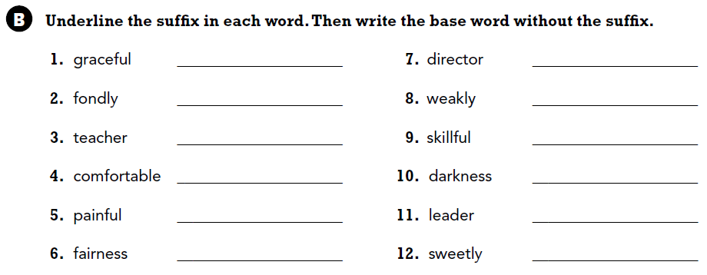

A noun is a person, place, thing, or idea. Write four nouns.

