Spelling / Grammar/ Punctuation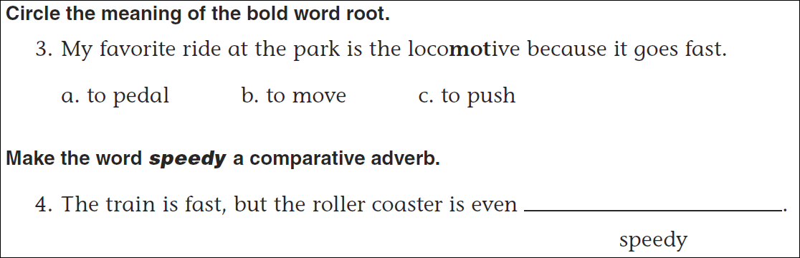
Math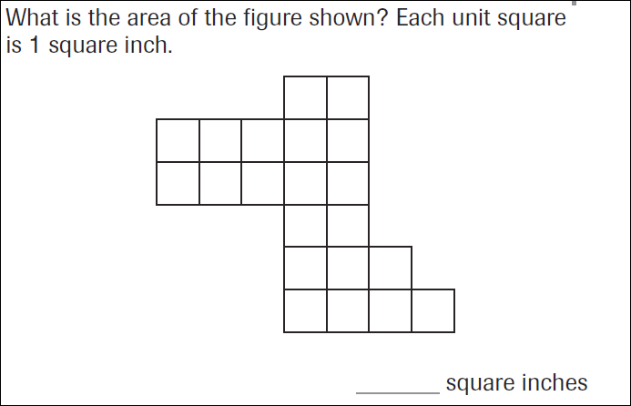
What is the perimeter of this shape? ___________
3x6=_____ | 3x7=_____ | 3x8=_____ | 3x9=_____

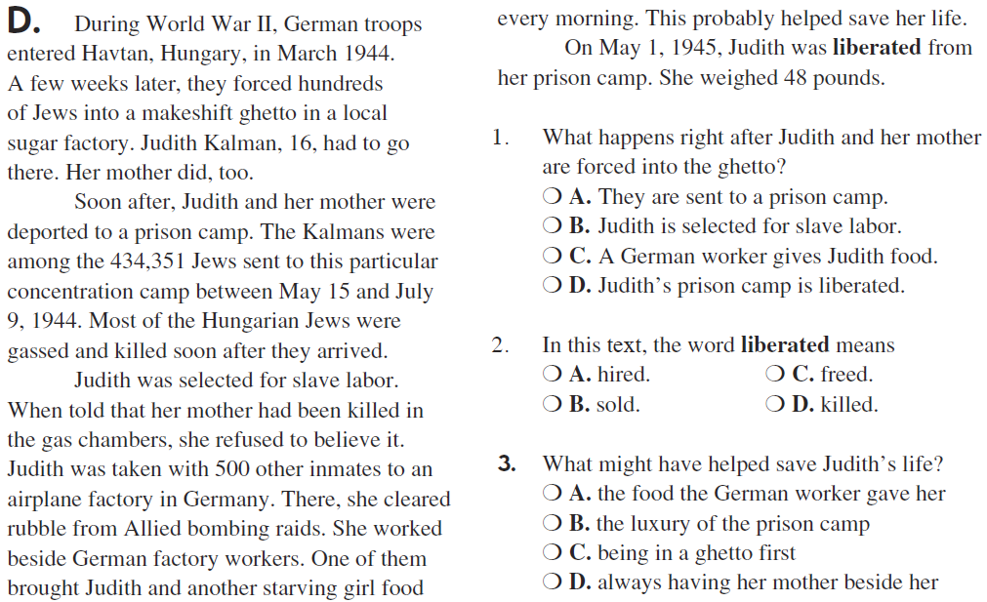
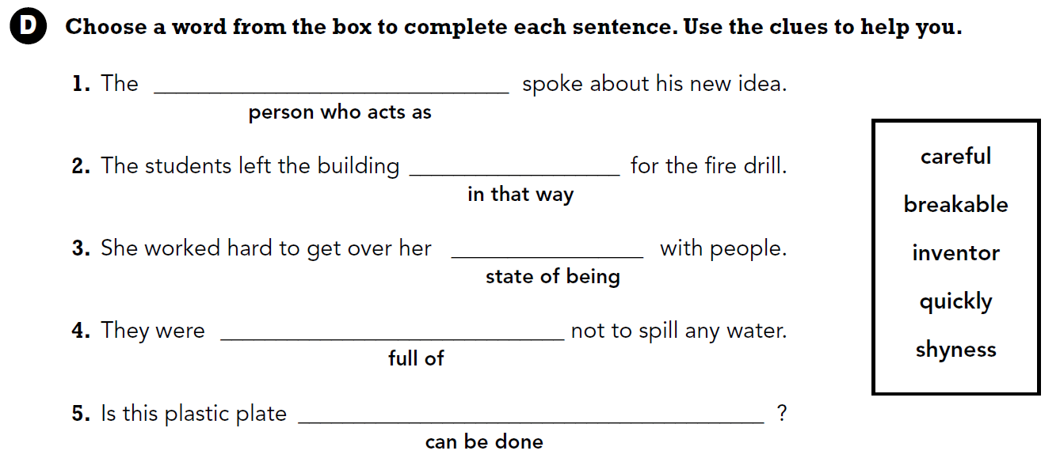

Verbs are action words. Write four verbs.

