Spelling / Grammar/ Punctuation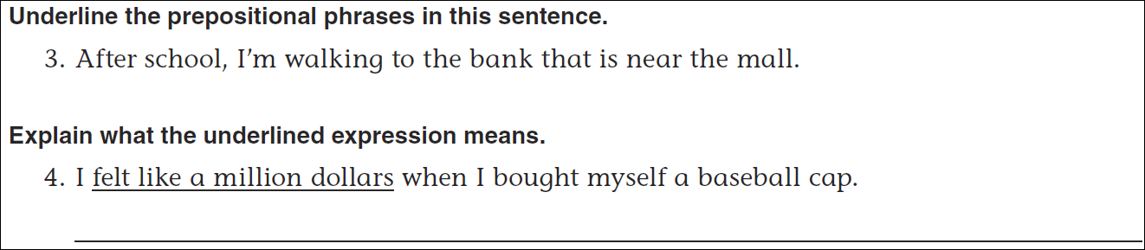
Math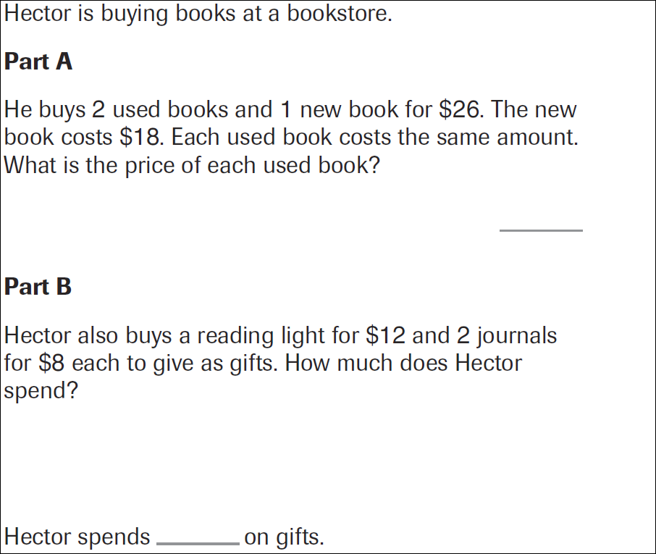
4x6=______ | 4x7=______ | 4x8=______ | 4x9=_______

