Spelling / Grammar/ Punctuation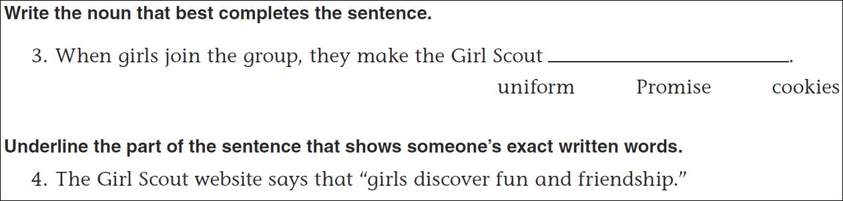
Math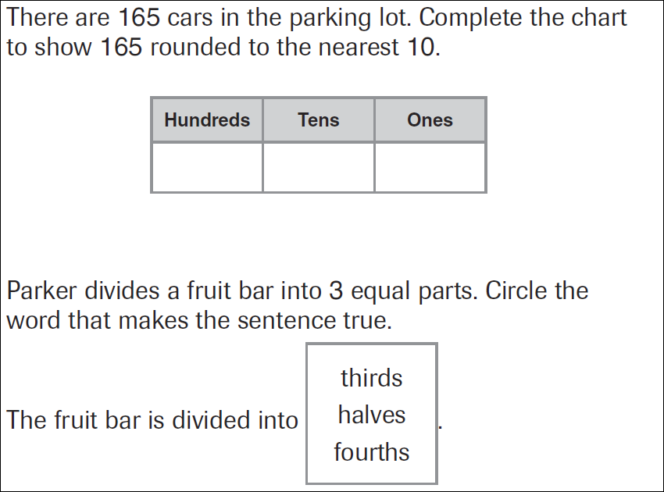
6x7=______ | 6x8=______ | 6x9=______ | 6x6=______

