Spelling / Grammar/ Punctuation
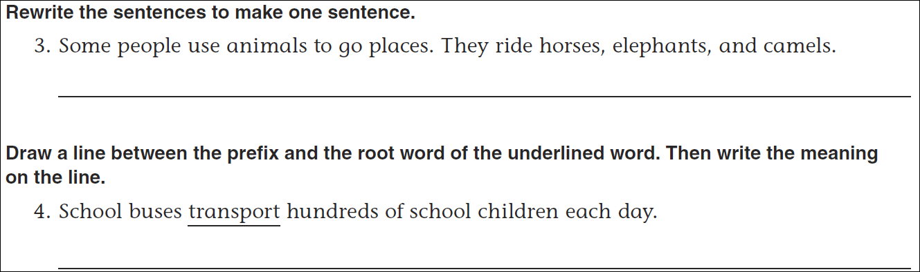
Math
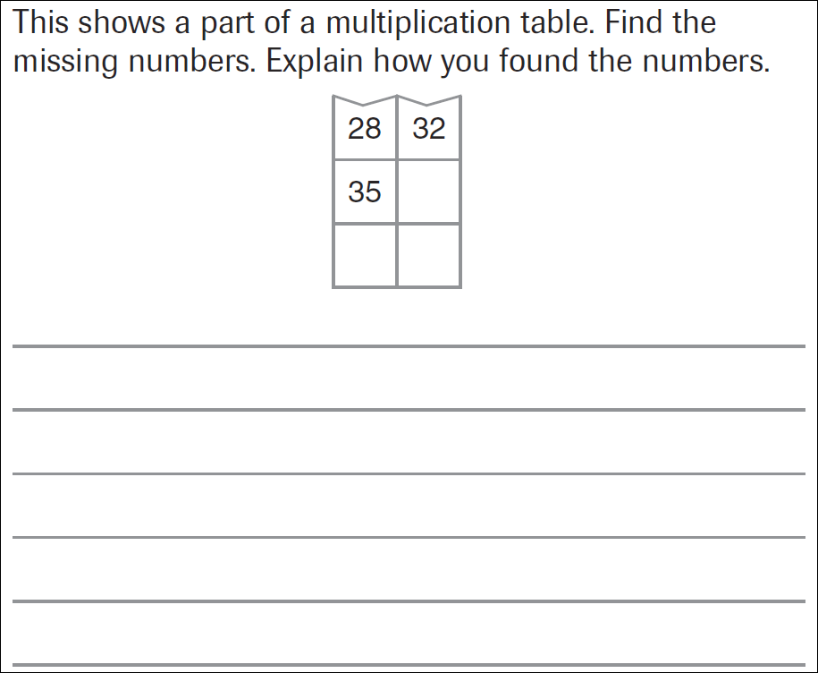

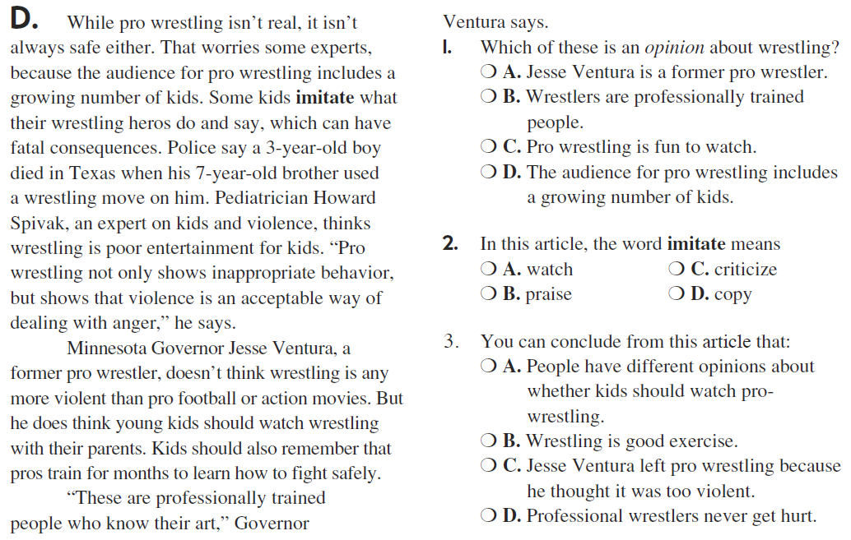
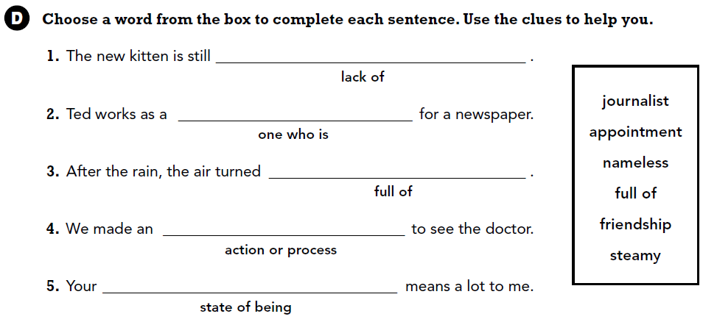

Adjectives describe nouns. Write four adjectives that describe a lion.

