Spelling / Grammar/ Punctuation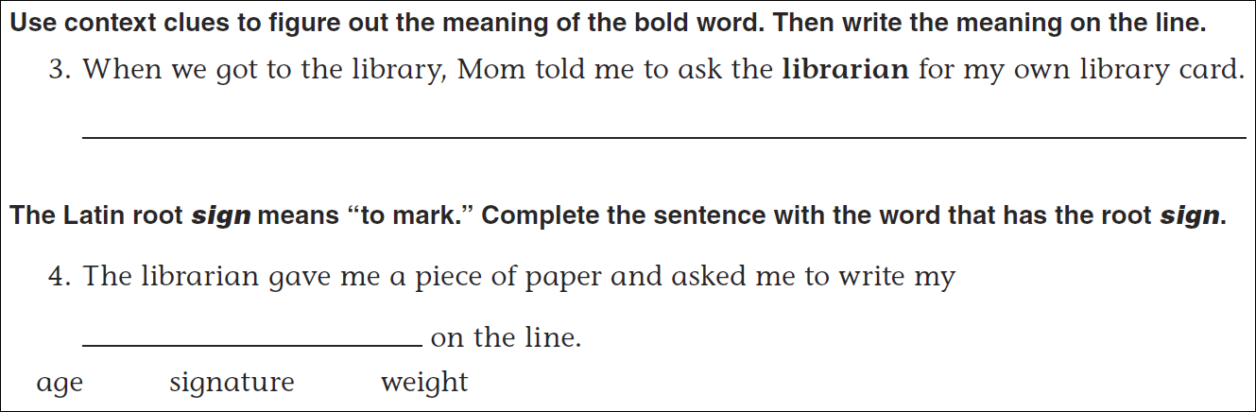
Math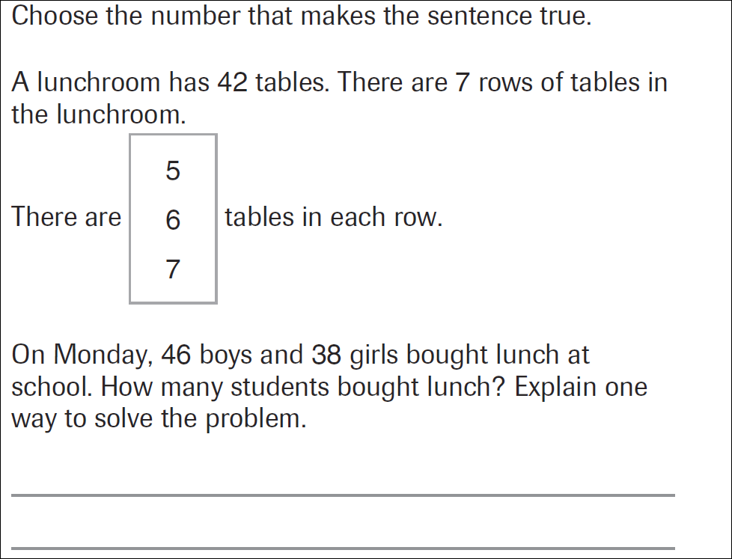
6x7=_____ | 7x7=______ | 8x7=_____ | 9x7=_____ | 10x7_____

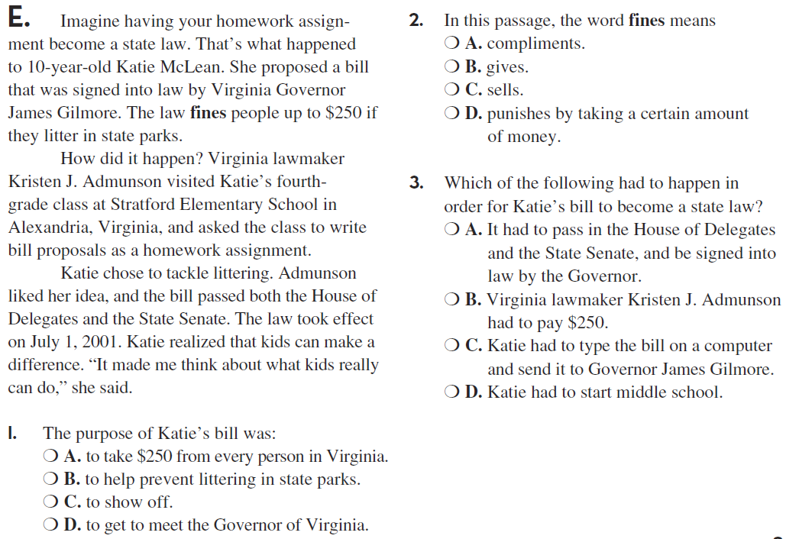
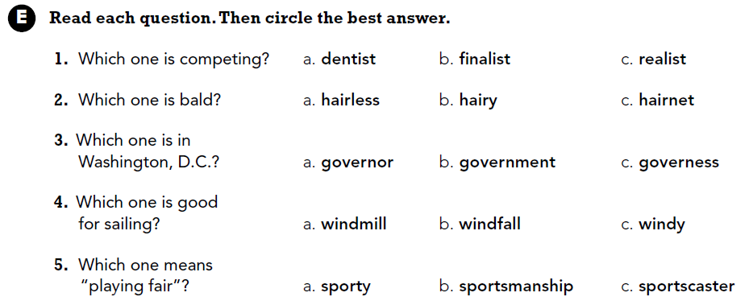

Adjectives describe nouns. Write four adjectives that describe a fish.

