Spelling / Grammar/ Punctuation
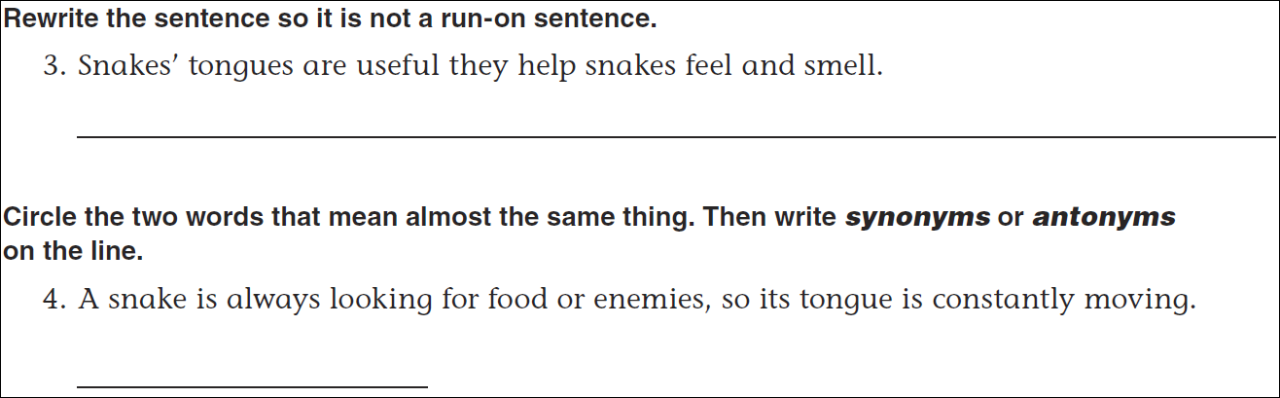
Math
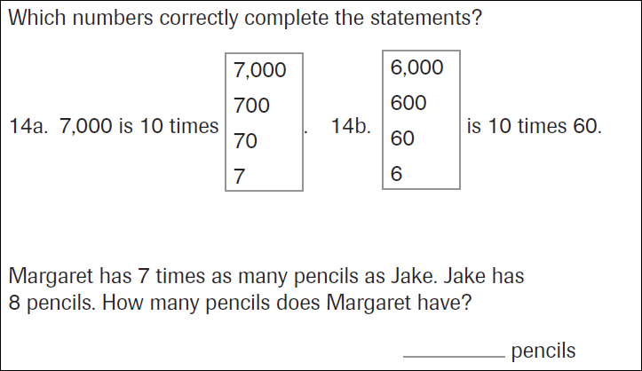
38 ÷ 5 = | 41 ÷ 5 = | 24 ÷ 5 = | 18 ÷ 5 =
32 ÷ 5 = | 47 ÷ 5 = | 28 ÷ 5 = | 13 ÷ 5 =

