Spelling / Grammar/ Punctuation
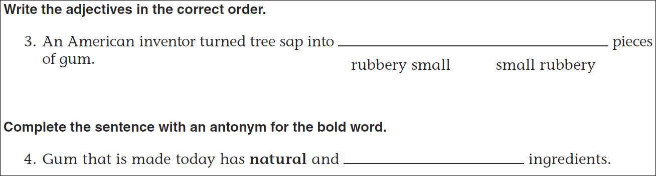
Math
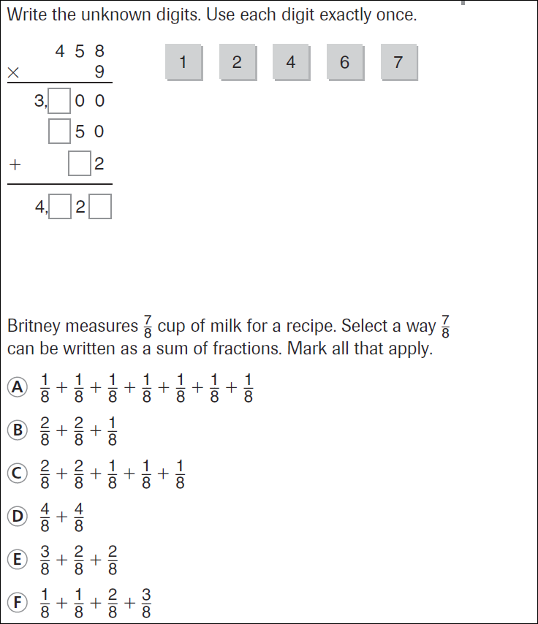
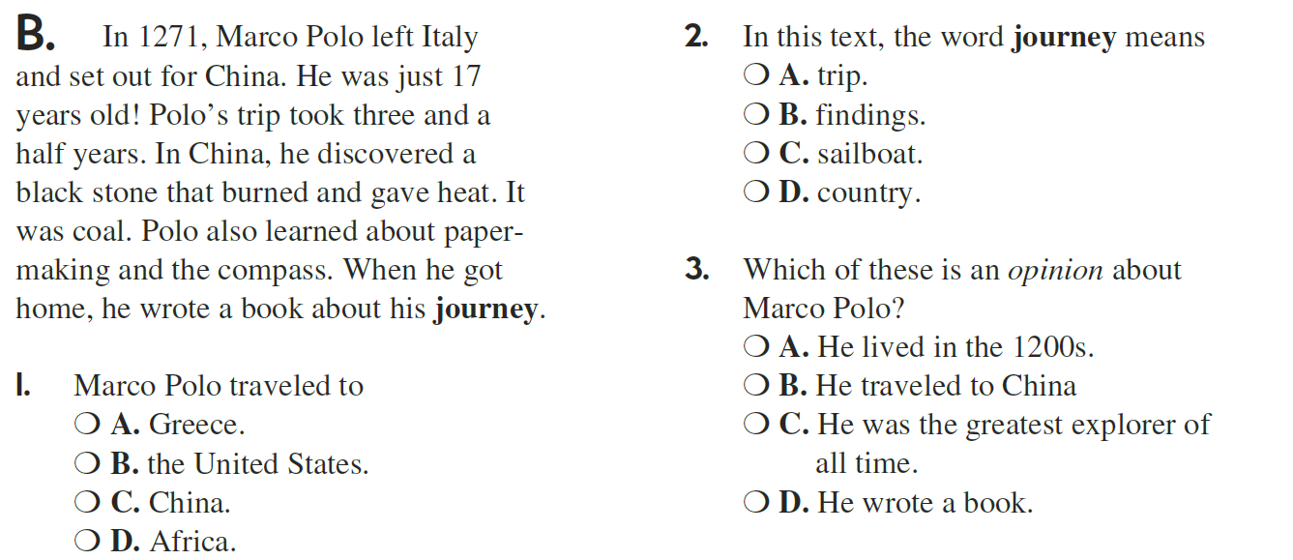
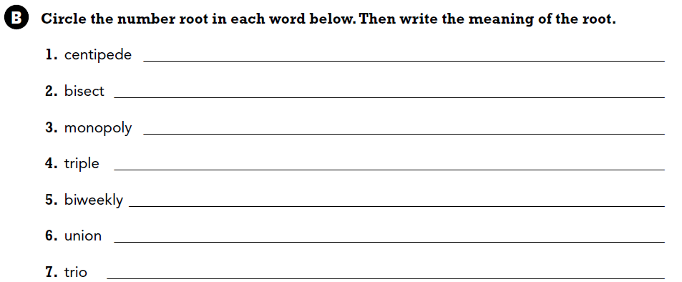

Use part of the question in your answer.
In a division problem, what is the answer called?

