Spelling / Grammar/ Punctuation
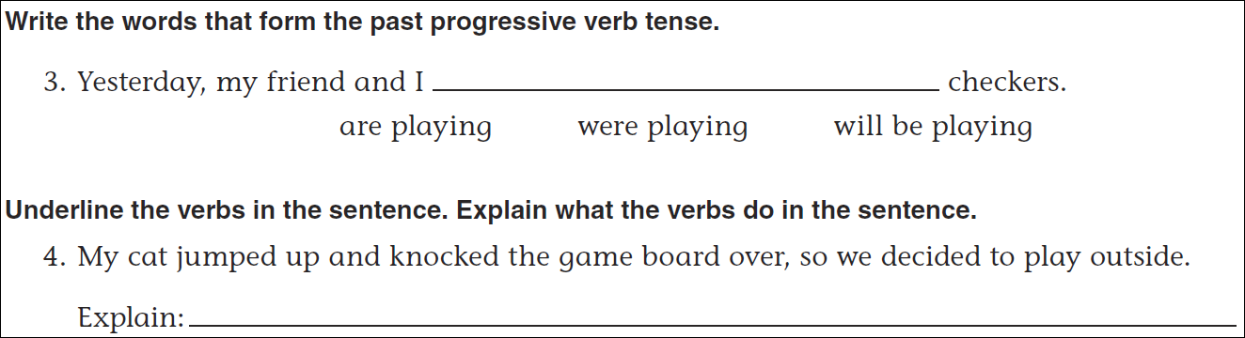
Math
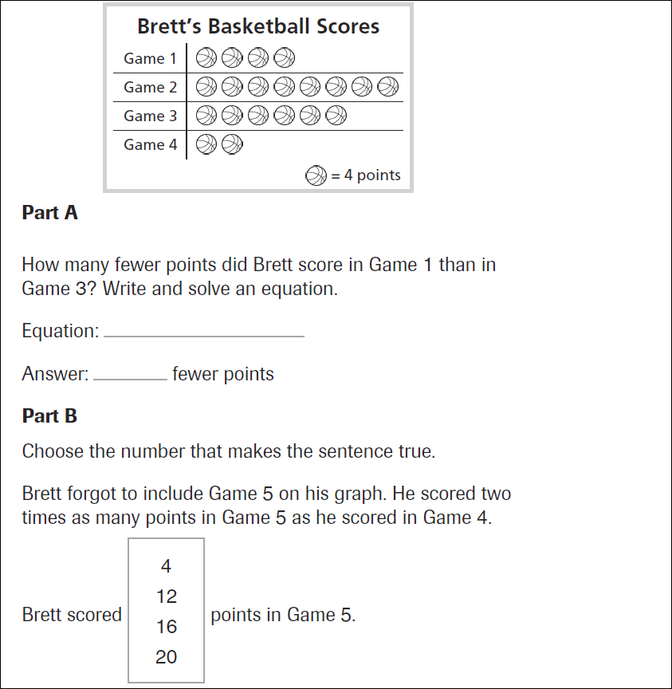
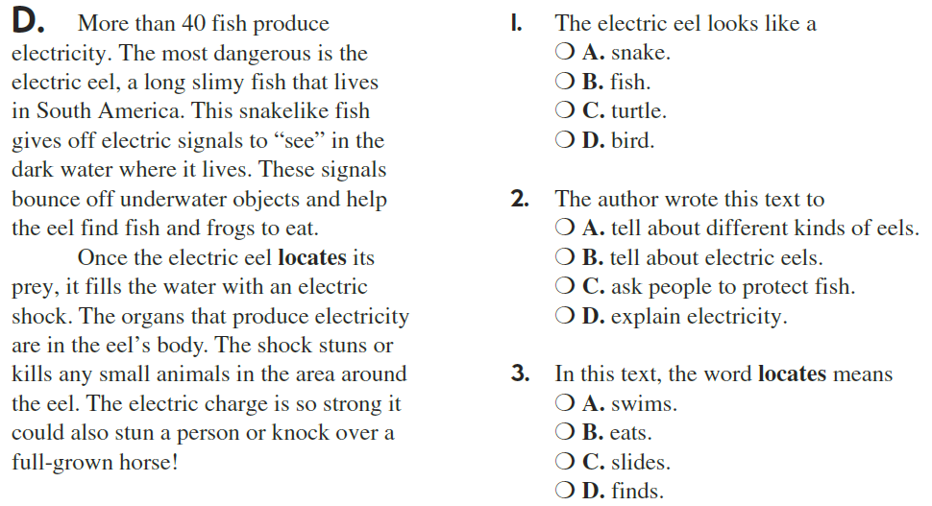

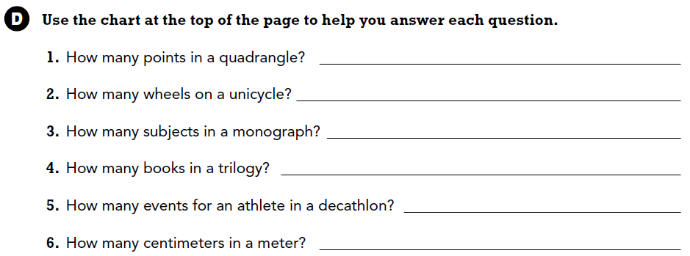

Use part of the question in your answer.
What is the top part of a fraction called?

