Spelling / Grammar/ Punctuation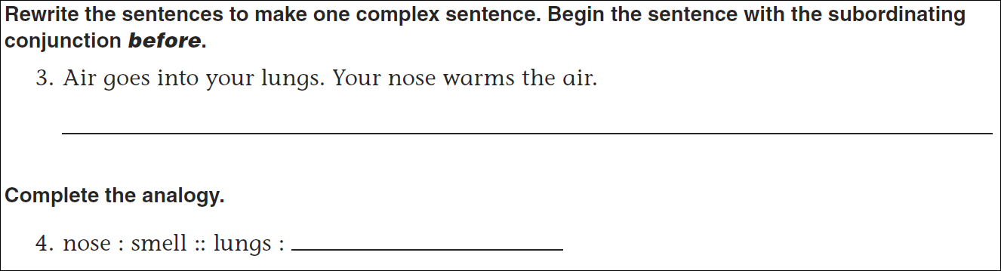
Math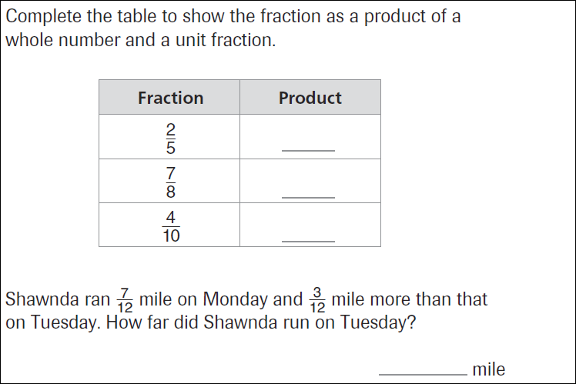
38 ÷ 8 = | 41 ÷ 8 = | 24 ÷ 8 = | 18 ÷ 8 =
32 ÷ 8 = | 47 ÷ 8 = | 28 ÷ 8 = | 13 ÷ 8 =

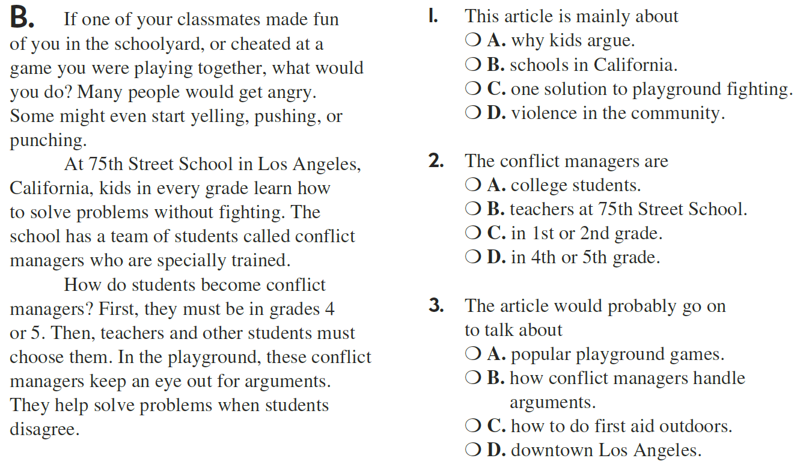

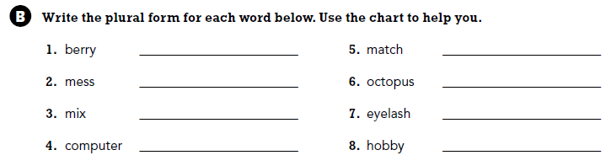

Use part of the question in the answer.
What is the answer to a subtraction problem called?

