Spelling / Grammar/ Punctuation
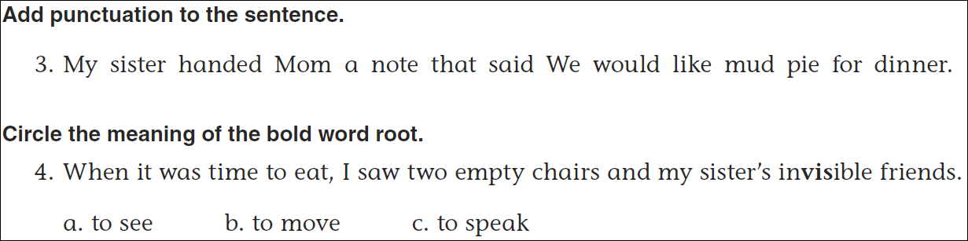
Math
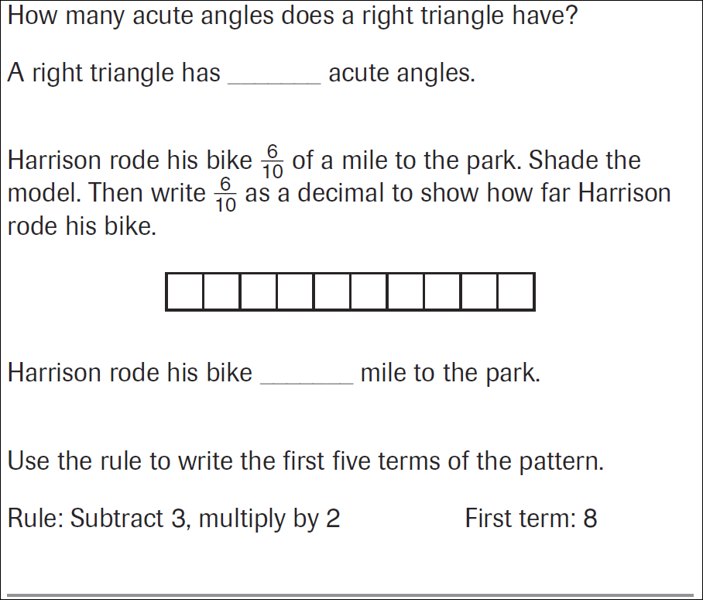

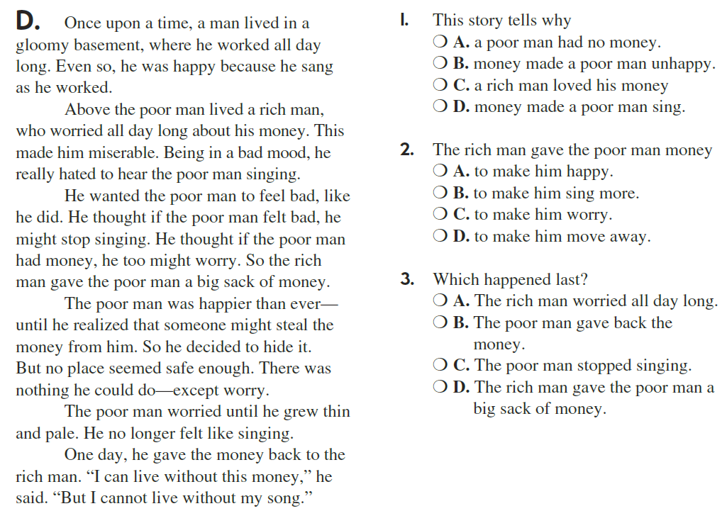

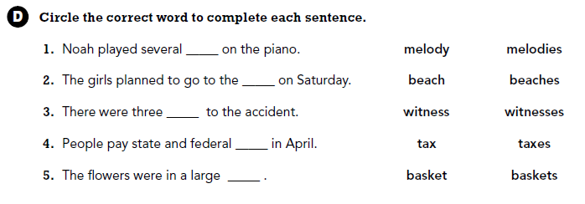

Use part of the question in the answer.
What is the bottom part of a fraction called?

