Spelling / Grammar/ Punctuation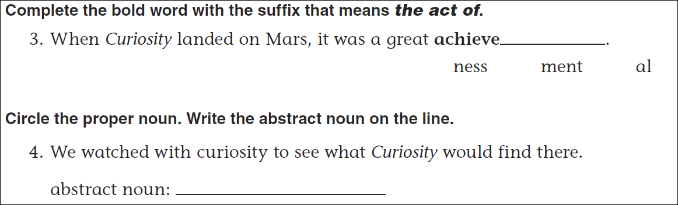
Math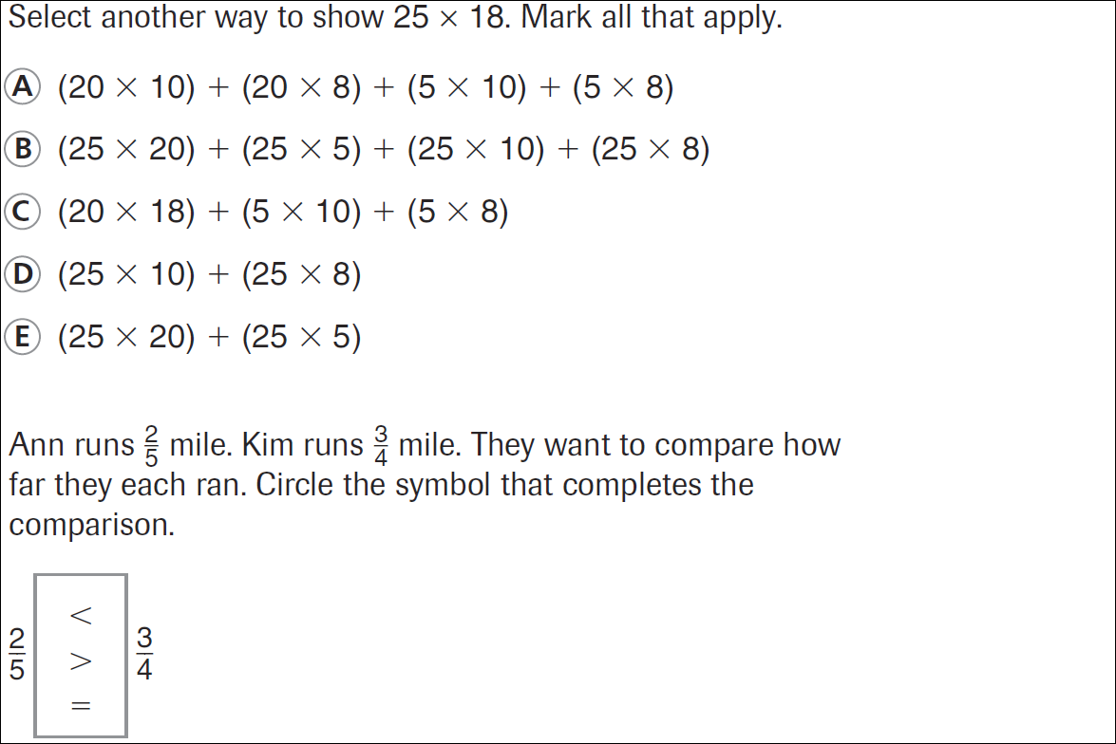
38 ÷ 9 = | 41 ÷ 9 = | 24 ÷ 9 = | 18 ÷ 9 =
32 ÷ 9 = | 47 ÷ 9 = | 28 ÷ 9 = | 13 ÷ 9 =

