Spelling / Grammar/ Punctuation
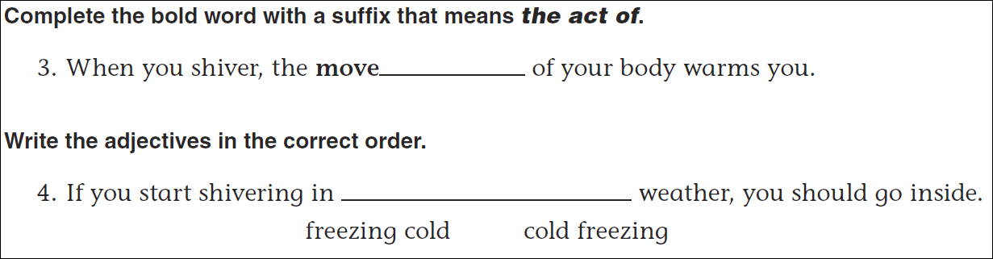
Math
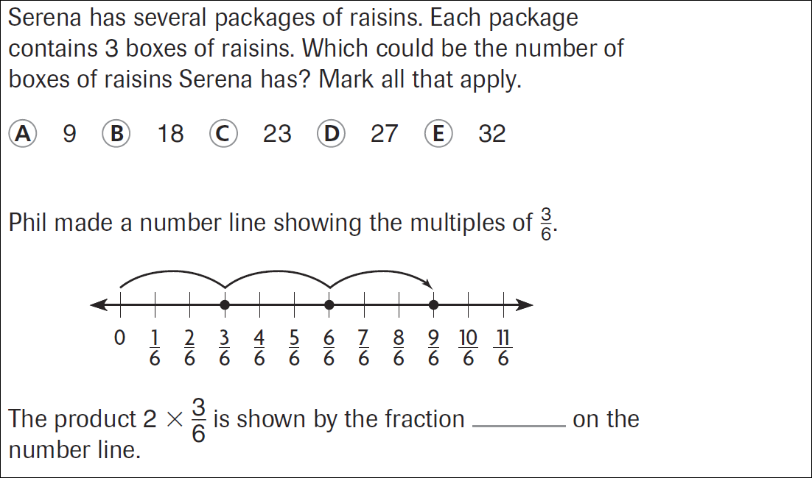

48 ÷ 5 = | 51 ÷ 5 = | 34 ÷ 5 = | 28 ÷ 5 =
42 ÷ 5 = | 57 ÷ 5 = | 38 ÷ 5 = | 23 ÷ 5 =

